CZ1106 Computer Organisation & Architecture
Summarized Notes

Part 1: ARM & Assembly Programming 3
Chapter 1: Introduction 3
Chapter 2: Data Organisation in Memory 3
2.1 Number Representation 3
2.2 Characters & Boolean 4
2.3 Array, String, Structure 5
2.4 Pointer 5
2.5 Data Alignment 6
Chapter 3: Instruction Organisation 7
3.1 Code & Data in memory (Mnemonics) 7
3.2 ARM Programmer Model 7
3.3 Basic Execution Cycle 7
Chapter 4: Addressing Modes 8
4.1 Summary 8
4.2 Immediate Addressing Rotation 8
4.4 Stack Implementation 9
4.5 PC-Related Addressing Modes 10
Chapter 5: Instruction Set 11
5.1: Data Transfer Instructions 11
5.2: Arithmetic Instructions 11
5.3: Logical, Shift & Rotate 11
5.4 Program Control Instructions 12
Chapter 6: Modular Programming 13
6.1 Subroutines 13
6.2 Parameter Passing 13
6.3 System Stack 13
6.3a Local Variables & Stack Frame 14
6.4 Nested Subroutine 15
6.5 Recursive Subroutine 15
Chapter 7: Flow Control Constructs 16
7.1 If-else 16
7.2 Switch 16
7.3 Loops 17
Chapter 8: Instruction encoding and ISA 18
8.1 Instruction Encoding 18
8.2 Overall instruction format (Arithmetic & Logic) 18
8.3 Branch Instructions 19
8.4 Load/Store Instructions 20
8.5 Fixed vs variable length instruction 20
Big Brain ASS Moves 20
Part 2: Hardware 23
Chapter 1: Computer Systems Overview 23
1.1 Signal Chain Subsystem 23
1.2 Electrical Signal Interface 23
1.3 Parallel Data Transfer 24
1.4 Serial Data Transfer 24
1.5 Direct Memory Access 25
1.6 Asynchronous Data Transfer 27
1.7a Data Transfer Mechanism - Polling 28
1.7b Data Transfer Mechanism - Interrupt 28
Chapter 2: Computer Memory 29
2.1 Computer Memory Introduction 29
2.2a Semiconductor Memories (Volatile) 29
2.2b Semiconductor Memories (Non-volatile) 30
2.2c Semiconductor Memories (Non-Volatile -- FLASH) 31
2.3a HDD & SSD (HDD) 31
2.3b Solid State Drives (SSD) 33
2.3c Data Center Storage & HMAR 34
Chapter 3: Cache & Virtual Memory 34
3.1 Cache 35
3.2 Virtual Memory 37
Chapter 4: Communication & User Interface 38
4.1 Universal Serial Bus 39
Chapter 5: Processor Pipeline 41
5.1: Overview of Simple CPU 42
Chapter 6: Computer Arithmetic 43
6.1 Number Systems 44
6.2 Fixed & Floating Point Number System 44
6.3 IEEE 754 45
6.4 Computer Arithmetic related consideration during coding 46

Part 1: ARM & Assembly Programming

Chapter 1: Introduction
Classes of Computers
- Supercomputer
- Microcomputer
- Embedded Systems

Computing Architecture
Harvard | Von Neumann
Separate memory 1 to store instructions/code and another to store the data | Shared memory Instructions/code and data are stored in the same memory

Chapter 2: Data Organisation in Memory
Memory Hierarchy (In order of precedence)
Registers | Fast access but limited numbers within CPU
Cache Memory | Fast access static RAM close to CPU (2-20ns access time)
Main Memory | Dynamic RAM/ROM for program storage (20-70ns access time)
Secondary Memory | Non-volatile, not fast connectivity

2.1 Number Representation
2 Basic Types - Whole number (int) or Floating point number (float) with decimal points

Signed vs Unsigned
Most processors interpret signed numbers using 2’s complement representation
Integers → Can be signed/unsigned | Floating Pt → always signed

Range
Use appropriate suffix to avoid wasting space Note: 1 byte = 8 bits
Data Type | Size  (in bytes)  1 byte = 8 bits | Min  (-2^{n-1} for signed, 0 unsigned)  ^{n is the number of bits} | Max  (2^{n-1} - 1 for signed, 2^{n} -1 for unsigned)  ^{n is the number of bits}
signed char | 1 | -128 | 127
unsigned char | 1 | 0 | 255
short int | 2 | -32,728 | 32,767
unsigned short int | 2 | 0 | 65,535
int/long int | 4 | -2,147,483,64 | 2,147,483,647
unsigned int | 4 | 0 | 4,294,967,295
long long int | 8 | -2⁶³ | 2⁶³ - 1
double | 8
long double | 12

Big & Little Endian -- only applicable to numbers
Big Endian | Example | Little Endian
MSB at 1st memory space  From Example:  0x23AB45CD | 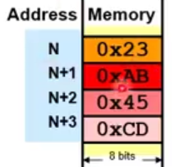 | LSB at 1st memory space  From Example:  0xCD45AB23

2.2 Characters & Boolean
ASCII Code → 7 bits, starting from 0x00 to 0x7F
- Numbers from 0x30 - 0x39
- Alphabets from 0x41

Unicode → 16 Bits, ASCII is a subset of unicode

Boolean → False = 0, True = non-zero
Needs only 1 bit in theory, but we store memory in bytes, wastage of 3 bits

2.3 Array, String, Structure
Arrays
- Elements accessed through respective offset from base address (BA)
- Offset = index * size of data type

Nested Arrays
- Int k[3][2] ⇒ each element array of size 2
- Offset for k[a][b] = sizeof(int) * (2*a)+b)

String Representation
ANSI C → array of characters terminating with NULL (0x00) | Pascal String → Length of string(in bytes) appended at start of string, followed by characters

Structure
- Each data type in declared structure occupies predefined consecutive locations based on data type size  - Space allocated only when variable inside is assigned a value | 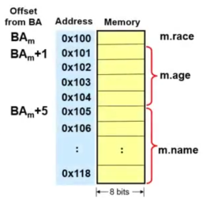

2.4 Pointer
- References memory variables, elements of structures & arrays
- Value pointer is address
- Size is fixed regardless of data type, dependent on processor address range
- Note: Memory is stored in bytes, so the amount of space required should be the CEILING(bits / 8)

2.5 Data Alignment
Basics
- Multi-byte data must be aligned to addresses that are the multiples of their sizes
- E.g. for int, address must start at one divisible by 4 bytes

Memory Interfacing & Data Alignment
- Interface consists of multiple 8-bit memory modules  - Made of 64-bit data word processor (aka data bus)  - Only one address pattern can exist on address bus during data transfer  - Misaligned data requires more cycles to transfer  - Data alignment varies on the width of the processor’s address bus | 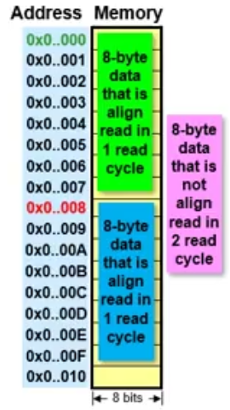

Data Aligned  - 3-most LSB only varies  - Address pattern ⇒ MSB to 4th LSB | Data Misaligned  - 4th LSB varies as well  - Use 2 cycles to process 2 address patterns
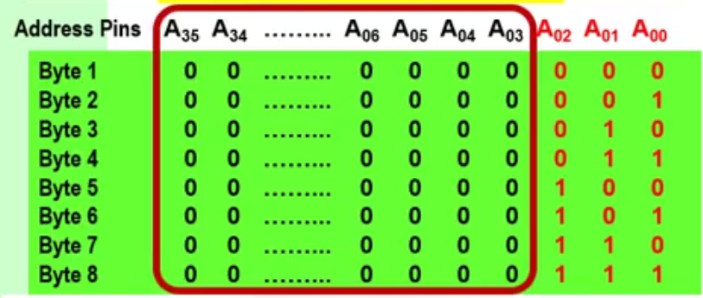 | 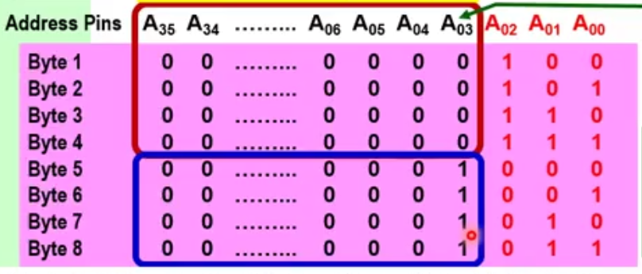

Data Padding
- Addition of meaningless bytes by compiler so that next element is aligned
- Structure ⇒ padding applied between variables ⇒ reorganise elements to minimize padding
- Array of structures ⇒ padding applied between the structures

Chapter 3: Instruction Organisation

3.1 Code & Data in memory (Mnemonics)
- Each instruction set is 4 bytes in memory (32bits)
- Code flows from lower to upper address
- Memory partitioned into code & data segments

General Instruction Overview
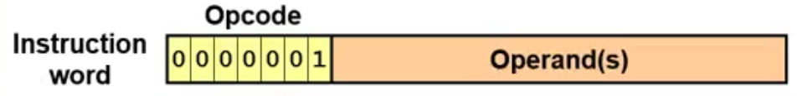
Opcode ⇒ type of instruction
Operands ⇒ variables

3.2 ARM Programmer Model
Multiple modes, focus on user mode
Visible Registers in User Mode:
R0-15  32-bit Registers x16 | General purpose register
R15  Program Controller (PC) | Keep track of program execution, used to alter sequential execution by modifying value  ⇒ Always 8 bytes ahead of current executed instruction
R13  Stack Pointer | Maintain space in memory (stack) used to temporarily store register info used later
R14  Link Register | Unique to ARM, Retrieves copy of PC when Brand with link (BL) instruction executed, acts as general purpose register otherwise
CPSR | Current Processor Status Register

Current Processor Status Register (CSPR) flags
- N - Negative ⇒ operation produces negative result
- Z - Zero ⇒ operation produces zero result
- C - Carry ⇒ operation produce carry out in the MSB
- V - Overflow ⇒ operation produces arithmetic overflow (for signed arithmetic operation)

3.3 Basic Execution Cycle
Performed by CPU: Fetch instructions ⇒ Decode Instructions ⇒ Fetch data ⇒ Execute

Chapter 4: Addressing Modes

4.1 Summary
Mode | Description | Example
Register Direct | Operand is content of specified register | MOV R1, R0
Immediate Addressing | Value is directly specified, preceded by # symbol | MOV R1, #3
Register Indirect | Value is accessed via address stored in register | LDR R1, [R0]
Register Indirect w/ offset | Adds offset value to indirect register to get effective addr | LDR R1, [R0,#4]  Effective Addr: R0 + 0x4
Register Indirect w/ index register | Adds contents of index register to get effective addr | LDR R1, [R0,R2]  Effective Addr: R0 + 0R2
Auto Indexing (Pre-index) | Keeps track of effective addr, compute EA before execution | LDR R1, [R0,#4]!  Effective Addr: R0 + 0x4, then R0 + 0x8
Auto Indexing (Post-index) | Keeps track of effective addr, compute EA after execution | LDR R1, [R0],#4  Effective Addr: R0, then R0 + 0x4

4.2 Immediate Addressing Rotation
ARM instructions are limited to 32 bits, of which 12 bits are allocated for the immediate addressing operand.
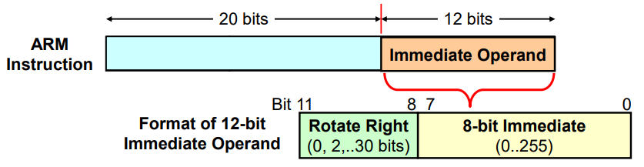 | The distance between the Most sig ‘1’ and least sig ‘1’ must be able to be represented a 8 bit block at max  No of remaining bits after 8 bit block must be even  Rotate right ⇒ How many bits must the 8 bit block situated at the end be rotated such that it is accurately represented by a 32 bit number
0x01200000 ⇒ 00000001001000000000000000000000  How it looks like in the instruction:  xxxxxxxxxxxxxxxxxxxxxxxx00010010  → Rotate Right by 12 bits (n=6) →  00000001001000000000000000000000 | 0x8000002 ⇒  00001000000000000000000000000010  How it looks like in the instruction:  xxxxxxxxxxxxxxxxxxxxxxxx10000010  → Rotate Right by 6 bits (n=3) →  00001000000000000000000000000010

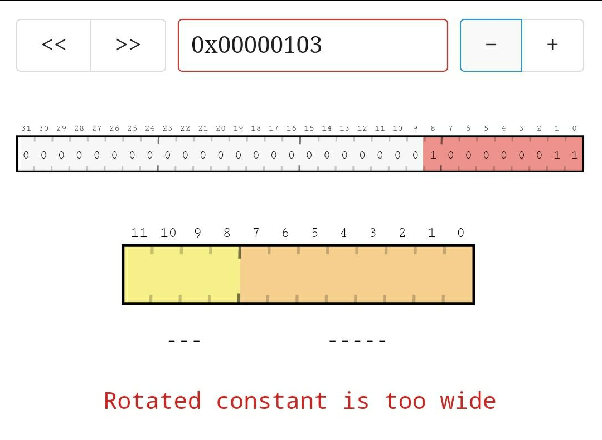 | 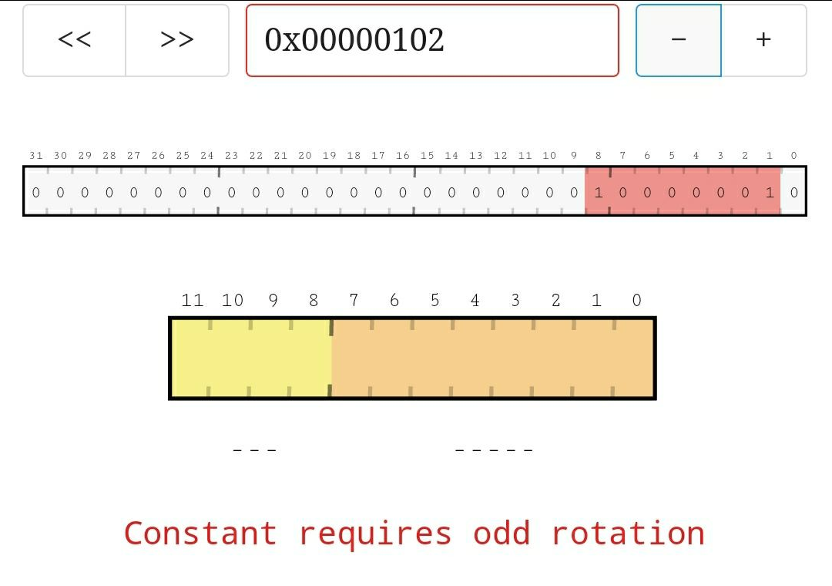
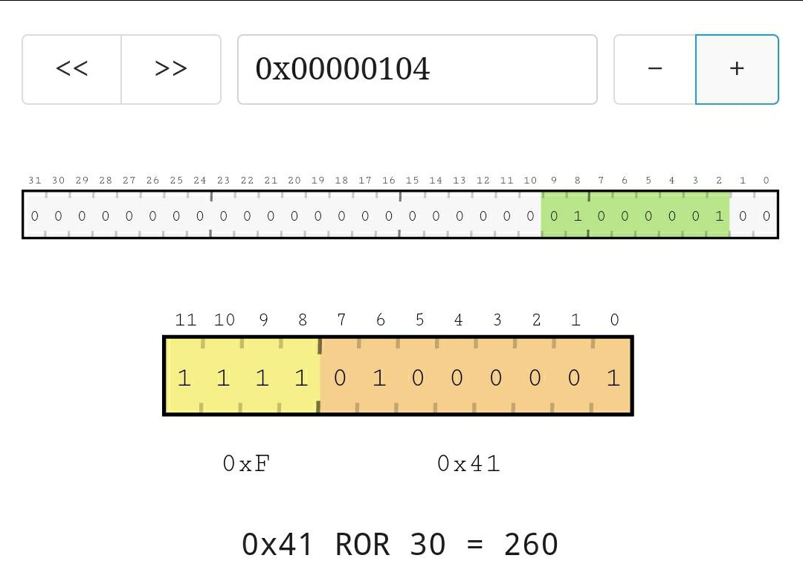 | 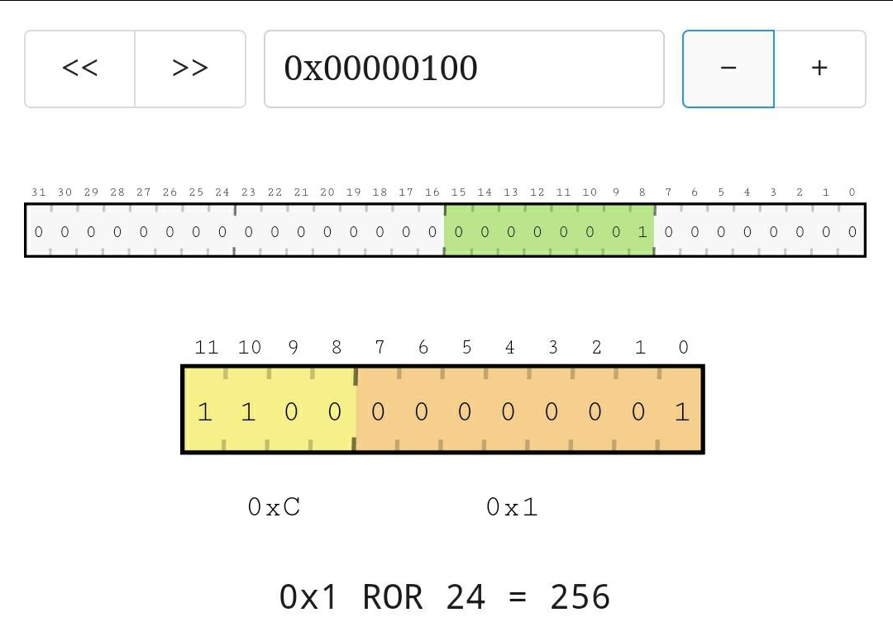

4.4 Stack Implementation
Direction | Descending  Grows towards lower memory | Ascending  Grows towards higher memory
Type | Full  SP points to valid item | Empty  SP points to available empty space

4.5 PC-Related Addressing Modes
Absolute Jump
Directly load the address into the PC ⇒ MOV PC,#0x60

Relative Jump
Offset added to PC to alter sequential order of execution. Supports position independent code. (Can be loaded anywhere in memory and still function)

Note: PC is 8-bytes ahead of the current executed instruction

Accessing Data
Using offset from the PC’s current value, calculated by Address of data - PC value

Example:
0x004 ADD PC,PC,#0 ;Relative jump to instruction at 0x00C
0x008 MOV R1,R0 ;Dummy instruction
0x00C ADD R1,PC,#0xEC ;Get the address of Var_A and store into R1
0x010 LDR R0,[R1] ;Load value of Var_A
…
0x100 0x1234567 ;Var_A

To relative jump to 0x00C, when the command at 0x004 is executed, PC is 8 bytes ahead, PC value ⇒ 0x004. To jump, set the PC value to 0x004 (in this case adding 0 to it and storing it into PC)

When command at 0x00C is executed, PC is 8 bytes ahead. PC value ⇒ 0x014
Therefore to calculate offset, 0x100 - 0x014 = 0x0EC

Chapter 5: Instruction Set

5.1: Data Transfer Instructions
Suffixes | Meaning
S | Set CSPR flags
N | Negate ⇒ bit wise inversion
B | Only copy single byte

5.2: Arithmetic Instructions
Operator | Description | NZVC Flags
ADDS R1,R1,R0 | Store R1+R0 into R1, | V = 1 when adding signed numbers (if overflow) C = 1 when adding unsigned numbers
SUBS R2,R0,#4 | Subtract 4 from R0 and store it into R2 ⇒ R0-4 | N = 1 when resultant is -ve  Z = 1 when resultant is 0  V = 1 when result outside of signed 32-bit range  C = 0 when A-B and A < B, 1 otherwise
RSBS R2,R0,#4 | Subtract R0 from 4 ⇒ 4-R0 (reverse of SUB)

Example: Convert -ve number to +ve Number
- Obtain 2’s cpl by inverting (MVN) then adding 1 (ADDS) to result
- Mov a value 0 into register r0, do SUB R1,R0,R1 ⇒ e.g. 0-(-5) = 5
- Use RSB R1,R1,#0 to obtain R1=0-R1 ⇒ 0-(-5) = 5

5.3: Logical, Shift & Rotate
We can use logical operators (AND, NOR, OR, XOR) to do boolean operations on the bits
Logical Instruction | Use | Pattern
AND | Clear specific bits | 1’s to pass, 0’s to clear
ORR | Set specific bits | 1’s to set, 0’s to pass
EOR | Complement specific bits | 1’s to flip, 0’s to pass

Shifts - Note: Need to add S suffix to influence carry flag
Logical Shift Left/Right (LSL/LSR)  Moves LSB/MSB respectively into the carry flag, replaced by 0’s  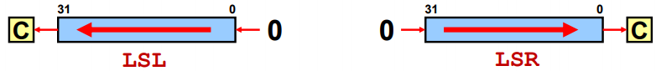 | Rotate Right (ROR)  LSB is copied into the carry bit and is moved into the MSB. Entire thing is shifted right  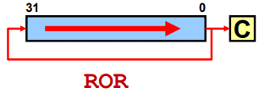
Rotate Right Extended (RRX)  LSB is moved into the carry bit, then into the MSB.  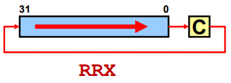 | Arithmetic Shift Right (ASR)  MSB is padded, LSB moved into the carry  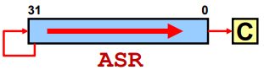

Performing Arithmetic with Shift
Multiply  ← Logical Shift Left ←  Multiply by 2^{n}, n is number of bits shifted | Unsigned Division  → Logical Shift Right→  Divide by 2^{n}, n is number of bits shifted | Signed Division  → Arithmetic Shift Right →  Divide by 2^{n}, Sign bit shifted into MSB

5.4 Program Control Instructions
CMP
Takes in 2 operands, subtracts source operand from destination register. i.e. CMP R1,R2 = R1-R2. CMP also sets the NZVC flags appropriately.

BCC Branch
CC represents the condition ⇒ Refer to Appendix 1, Table 1 for Condition Code suffixes
As a result of the CMP command we have some for example:
- EQ ⇒ Equal, Checks Z flag. (5 - 5 = 0, Z flag = 1)
- HI ⇒ Higher (Unsigned), Checks C and Z flag (5-4 = 1, C flag = 1, Z flag = 0)

Commands with CC
The CC Condition can be included at the end of the command to only execute based on the result
E.g. MOVEQ R1,R2 ⇒ Only copy R2 into R1 if the Z flag is 1

Chapter 6: Modular Programming

6.1 Subroutines
BL & BX
- BL ⇒ Branch with link makes the subroutine call. Return address (Addr of BL command +4) OR (PC Contents - 4) stored in Link Register (R14)
- BX ⇒ BX LR returns from subroutine. VisUAL does not support BX LR, use MOV PC,LR instead (same thing)

6.2 Parameter Passing
3 basic methods - Registers, Memory block, System Stack

Registers
Parameters passed into the register before calling subroutine, limited to available registers.
R0-R3 ⇒ Pass argument variables, used to return values from subroutine | R4-R11 ⇒ Holds local variables, not for passing arguments. Must be preserved in subroutine (store a copy in stack before use)
R12 ⇒ Scratchpad register, does not need to be preserved, sometimes used as a return register

Using Memory
Parameters consolidated into a block of memory, passed to the subroutine via an address register.

6.3 System Stack
- First In, Last out. Maintained Stack Pointer (SP/R13), points to top item of stack
- Can grow towards lower or higher memory addresses. Generally preferred to grow lower, start from the max address
- Stack can then grow without much concern for remaining space, has natural separation between program and data
- We generally prefer Full Descending format for stack

Stack Operations
Push - Overrides previously popped values | Pop - Popped values remain in memory, can still be accessed (but can be overwritten)
Use STR instruction, decrease stack pointer before storing (Pre-index)  STR R0,[SP,#-4]! | Use LDR instruction, increase stack pointer after (Post-index)  LDR R0,[SP],#4
Push multiple registers  STMFD SP!,{List of Registers} | Pop multiple registers  LDMFD SP!,{List of Registers}  e.g. R0-R3 or R0,R2 NOTE: Pushes R3 first then R2 then R0
Passing Parameters
By Value → Actual value of the data is passed into subroutine | By Reference → Address to the value of data is passed into subroutine

Transparent Subroutines
Do not affect any CPU resources - preserve registers used by saving them before entry and restoring them upon exit of subroutine
- Local registers used by subroutine (R4-11) must be stored in the stack before entry
i.e. STMFD SP!,{R4-R11}
- Restored on from stack before exiting subroutine
i.e. LDMFD SP!,{R4-R11}

Accessing Variables
- Parameters pushed into stack first  - Used registers stored before entering subroutine  To Access variables (in this case Address of Answer):  LDR R4,[SP,#12]  Offset of #12 is because we saved 3 registers and 3*4 = 12 bytes | 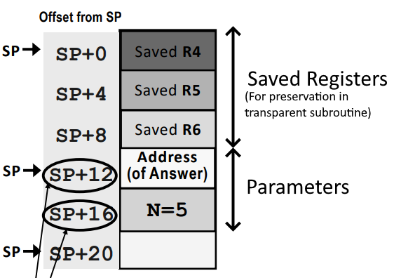

6.3a Local Variables & Stack Frame
Local Variables
Scope and lifespan exist only during execution of subroutine
- Memory storage for variables created on entry into subroutine
- Released on exit from subroutine
- Stack Frame ⇒ System stack creates temp space for local variables

Stack Frame
 | Frame Pointer (R11) | Stack Pointer
Creation | Push contents of R11 into stack  Set R11 = Address of top of stack (SP) | No need to create, already there
Accessing | Access variables by adding -ve offset to R11  e.g. LDR R1,[R11,#-4] to access 1st variable | Access variables by adding +ve offset to SP  e.g. LDR R1,[SP,#12] to access 1st variables, assuming there are 3 variables
Destroy | Set SP to R11 (i.e. FP)  Pop the stack into R11 to restore R11’s values | Set SP to its address + offset of the size of the stack frame
Pro/Con | Less efficient, but more flexible | More efficient, less flexible (can't add a new variable on top)

Overview of the Stack
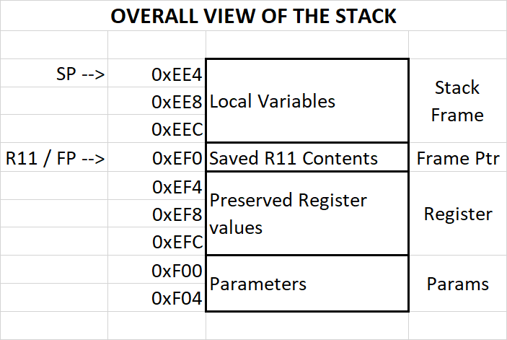

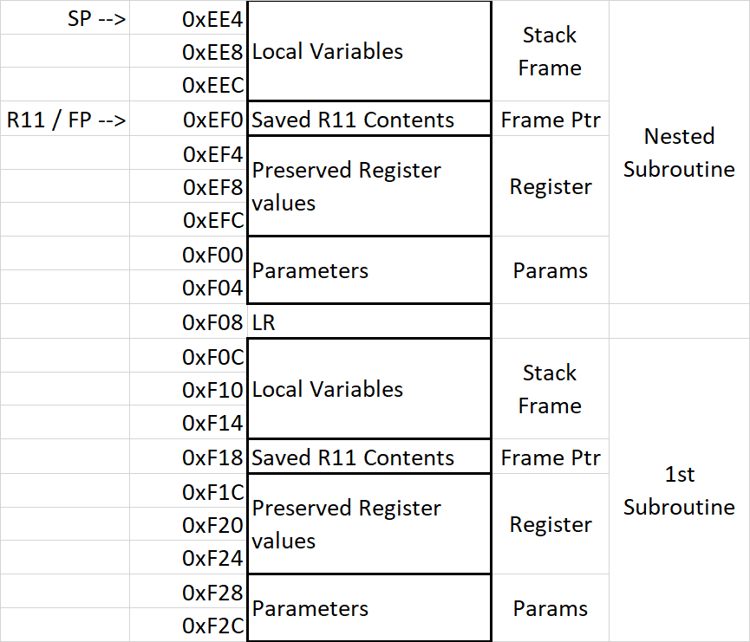
6.4 Nested Subroutine
When calling another subroutine within a subroutine, we get stuck in the 2nd last called subroutine as the LR is overwritten
- Store the LR in the system stack
- Save it before any BL instruction or the beginning of any subroutine

6.5 Recursive Subroutine
Calls itself within its own body.
- Store LR in the system stack
- Need to find a condition that allows the BL Recur to skip to avoid infinite recursion as well

Chapter 7: Flow Control Constructs

7.1 If-else
Imitate if-else statements do not produce efficient assembly code.
⇒ Flip the if-condition and use a branch to skip the if-block

Alternatively, only execute commands using CC condition flags
e.g. ADDEQ R1,R1,#1 only executes if Z flag = 1

Compound Conditions
Evaluated from left to right, arrangement of conditions improves efficiency
AND (&&)  - Keep least likely true condition on left  - On first false condition, skip the block | OR (||)  - Keep most likely true on left  - On first true, skip other condition tests  - Flip last condition and branch to skip the whole block

Branchless Logic
BCC may result in costly flushing operations when wrong next instruction prefetch into CPU pipeline.
Exploit arithmetic relationships to transform test condition to corresponding desired outcome

7.2 Switch
Close & Narrow Range of values ⇒ Jump Table
When switch has close & narrow a jump table that contains the addresses of the relevant code that should be run is more efficient. To addresses of each case, offset is applied.
switch(x){  case -1:  {s1}  case 1:  {s2}  case 2:  {s3}  default:  {s4}  } | Case | Addr | Contents
 | -1 | 0x80 | Address of s1
 | 0 | 0x84 | Address of s4 (note there is no case for 0, so we assign it the default addr)
 | 1 | 0x8C | Address of s2
 | 2 | 0x90 | Address of s3
 | 3 | 0x94 | Address of s4 (We will set x to 3 if it is out of range)
The base address for our jump table is 0x84 for the offset to be applied accurately.
If x < -1 or > 2, we will set x to 3 before accessing the jump table
To access address:
MOV PC,[R0,R1,LSL,#2]⇒ PC = Base_Addr + (x*4)
(R0 contains our base addr and R1 contains value of x)
Random & Wide Values ⇒ Fork Algorithm
Where the values of the case statements are too random or wide apart, the jump table size will be too large. Implement a cascade of if-else statements instead.
Switch Statement | Converted to if else | Forked if else
switch(x){  case 1: {s0}  case 10: {s1}  case 100: {s2}  case 1000: {s3}  } | if(x==1) {s0}  else if (x==10) {s1}  else if (x==100) {s2}  else if (x=1000) {s3} | if(x<=10){  if(x==1) {s0}  else if (x==10) {s1}  }else{  if(x==100) {s2}  else if (x==1000) {s3}  }

7.3 Loops
Types of Loops
Pre-Test → Test condition before executing. Skip if condition not met | Post-Test → Execute 1 loop iteration first then test

While Implementation → Pre-Test
- Invert the check condition
- Branch to exit loop if condition not met
- Run loop segment and always branch back to check condition

Do While → Post-Test
- Run loop segment first
- Check condition (not flipped)
- Branch back to loop segment if condition met

For Loop → Pre-Test
- Uses a counter register to keep track of iterations
- Similar to while implementation
- If value of counter register not used in loop segment → Optimize by convert to post-test (similar to do-while), decrement counter, and check for zero

Chapter 8: Instruction encoding and ISA

8.1 Instruction Encoding
Instructions are encoded in a 32-bit word
Instruction type, operand(s) and conditions for conditional execution are encoded

8.2 Overall instruction format (Arithmetic & Logic)
Arithmetic & Logic Instructions
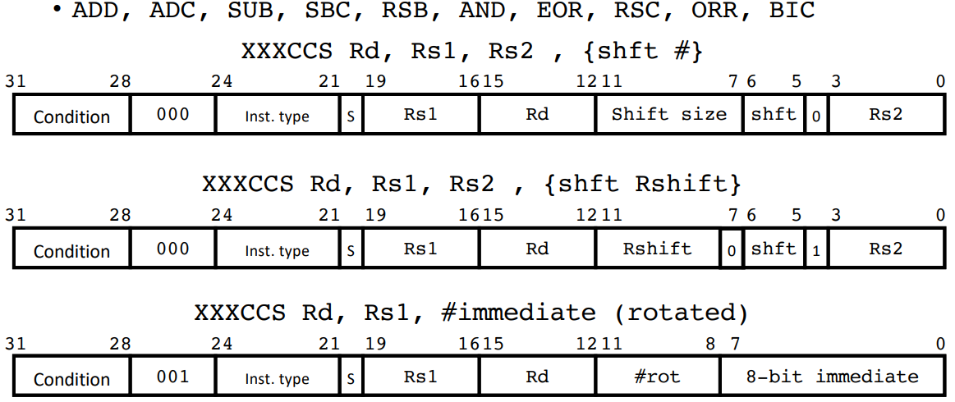

Comparison
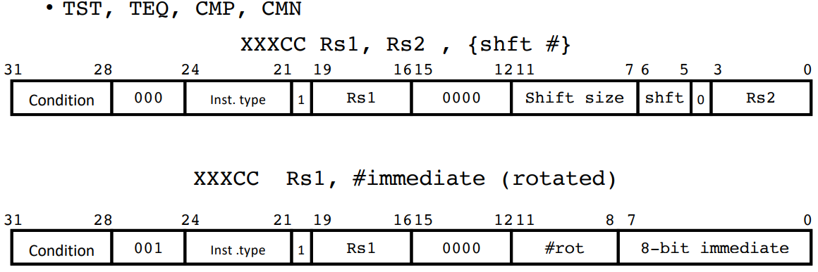

MOV Instructions 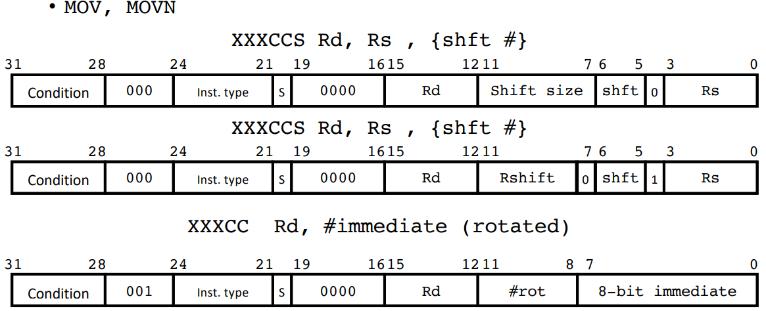
(Shift & rotate instructions are encoded as MOV instructions)
LSL R1, R2, #5 ⇒ MOV R1, R2, LSL #5
Condition Codes - 4 bits, 16 different types  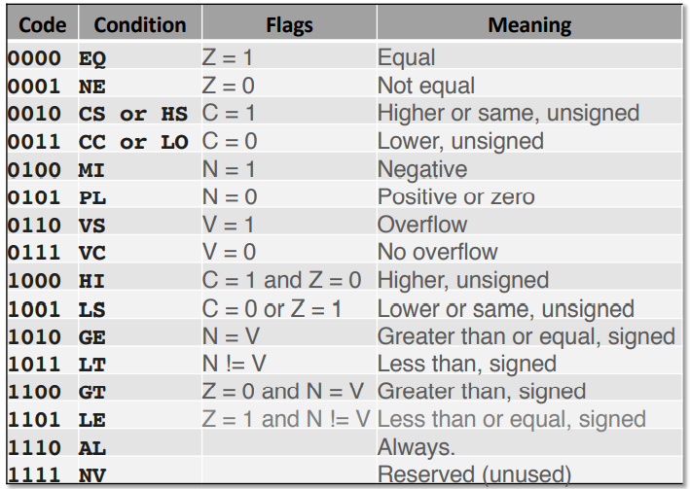 | Instruction Codes - 4 bits, 16 instructions  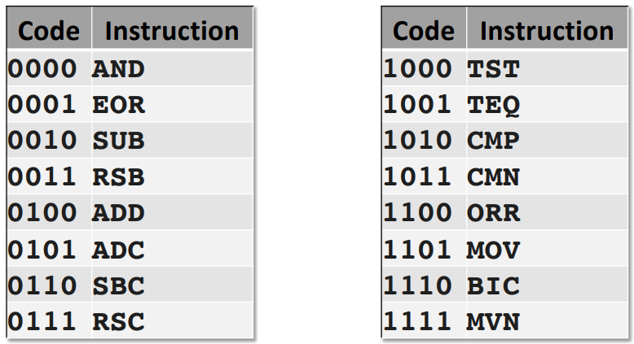  Registers - 4 bits to represent 16 registers

8.3 Branch Instructions
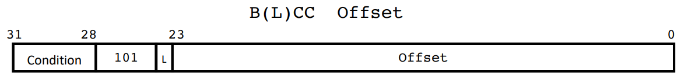
26 bits offset shifted to the right by 2 (branching to word addresses) calculated by the assembler
Note: Branch Range is +-32Mbytes

8.4 Load/Store Instructions
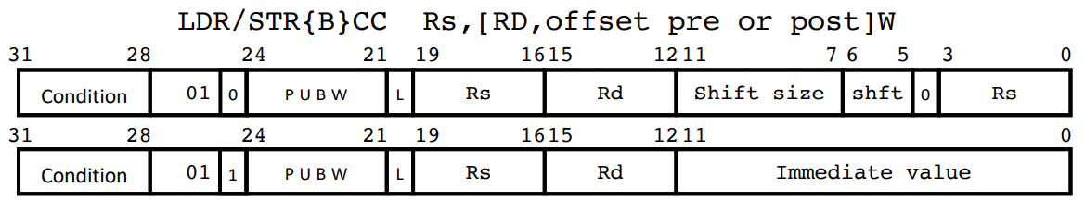
- L bit determines load (1) or store (0)
- P bit determines indexing pre (1) or post (0)
- U determines offset direction add (1) or subtract (0)offset
- B determines byte (1) or word (0) access
- W is for write back (!) of the offset

Multiple (For stack)
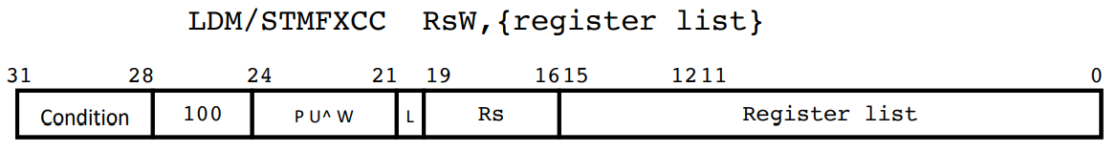

^ is a ‘dont care’
Register list is a set of 16 bits that represent each register. Order from MSB to LSB as follows:
PC LR SP R12 R11 R10 R9 R8 R7 R6 R5 R4 R3 R2 R1 R0

8.5 Fixed vs variable length instruction
ARM is fixed length, other types like intel instructions vary from 1 to 17 bytes long

Variable length instruction ⇒ Require multi-fetch and decode ⇒ More flexible (but complex) & compact instruction set

Using Registers
- Operations using registers faster than those involving memory
- Data transfer between registers and ALU faster as physically closer proximity
- Keep as much as computations within registers to speed up code execution

Implication of higher register count
- Increasing overheads
- Takes up space in the silicon die
- Connections to various busses make routing & multiplexing more complex
- Increases operand size during instruction encoding

Big Brain ASS Moves
(So big even my smol brain was like WTF)
Elementary Number Operations
2’s Complement | MVN R0,R0  ADD R0,R0,#1
Convert number to -ve | RSB R1,R1,#0
Check if number is even | ANDS R1,R1,#1 ;if even Z flag = 1  BEQ even  BNE odd
Multiplication ( ← To the left ← )
Multiplying by a number not 2^{n} (e.g. 9 or 7) | ADD R1,R1,LSL,#2 ;multiply by 9  RSB R1,R1,LSL,#2 ;multiply by 7  (Note: 1+8 = 9, 8 - 1 = 7)
Swapping
Swap 2 registers w/o 3rd register | EOR R1,R1,R2  EOR R2,R1,R2  EOR R1,R1,R2

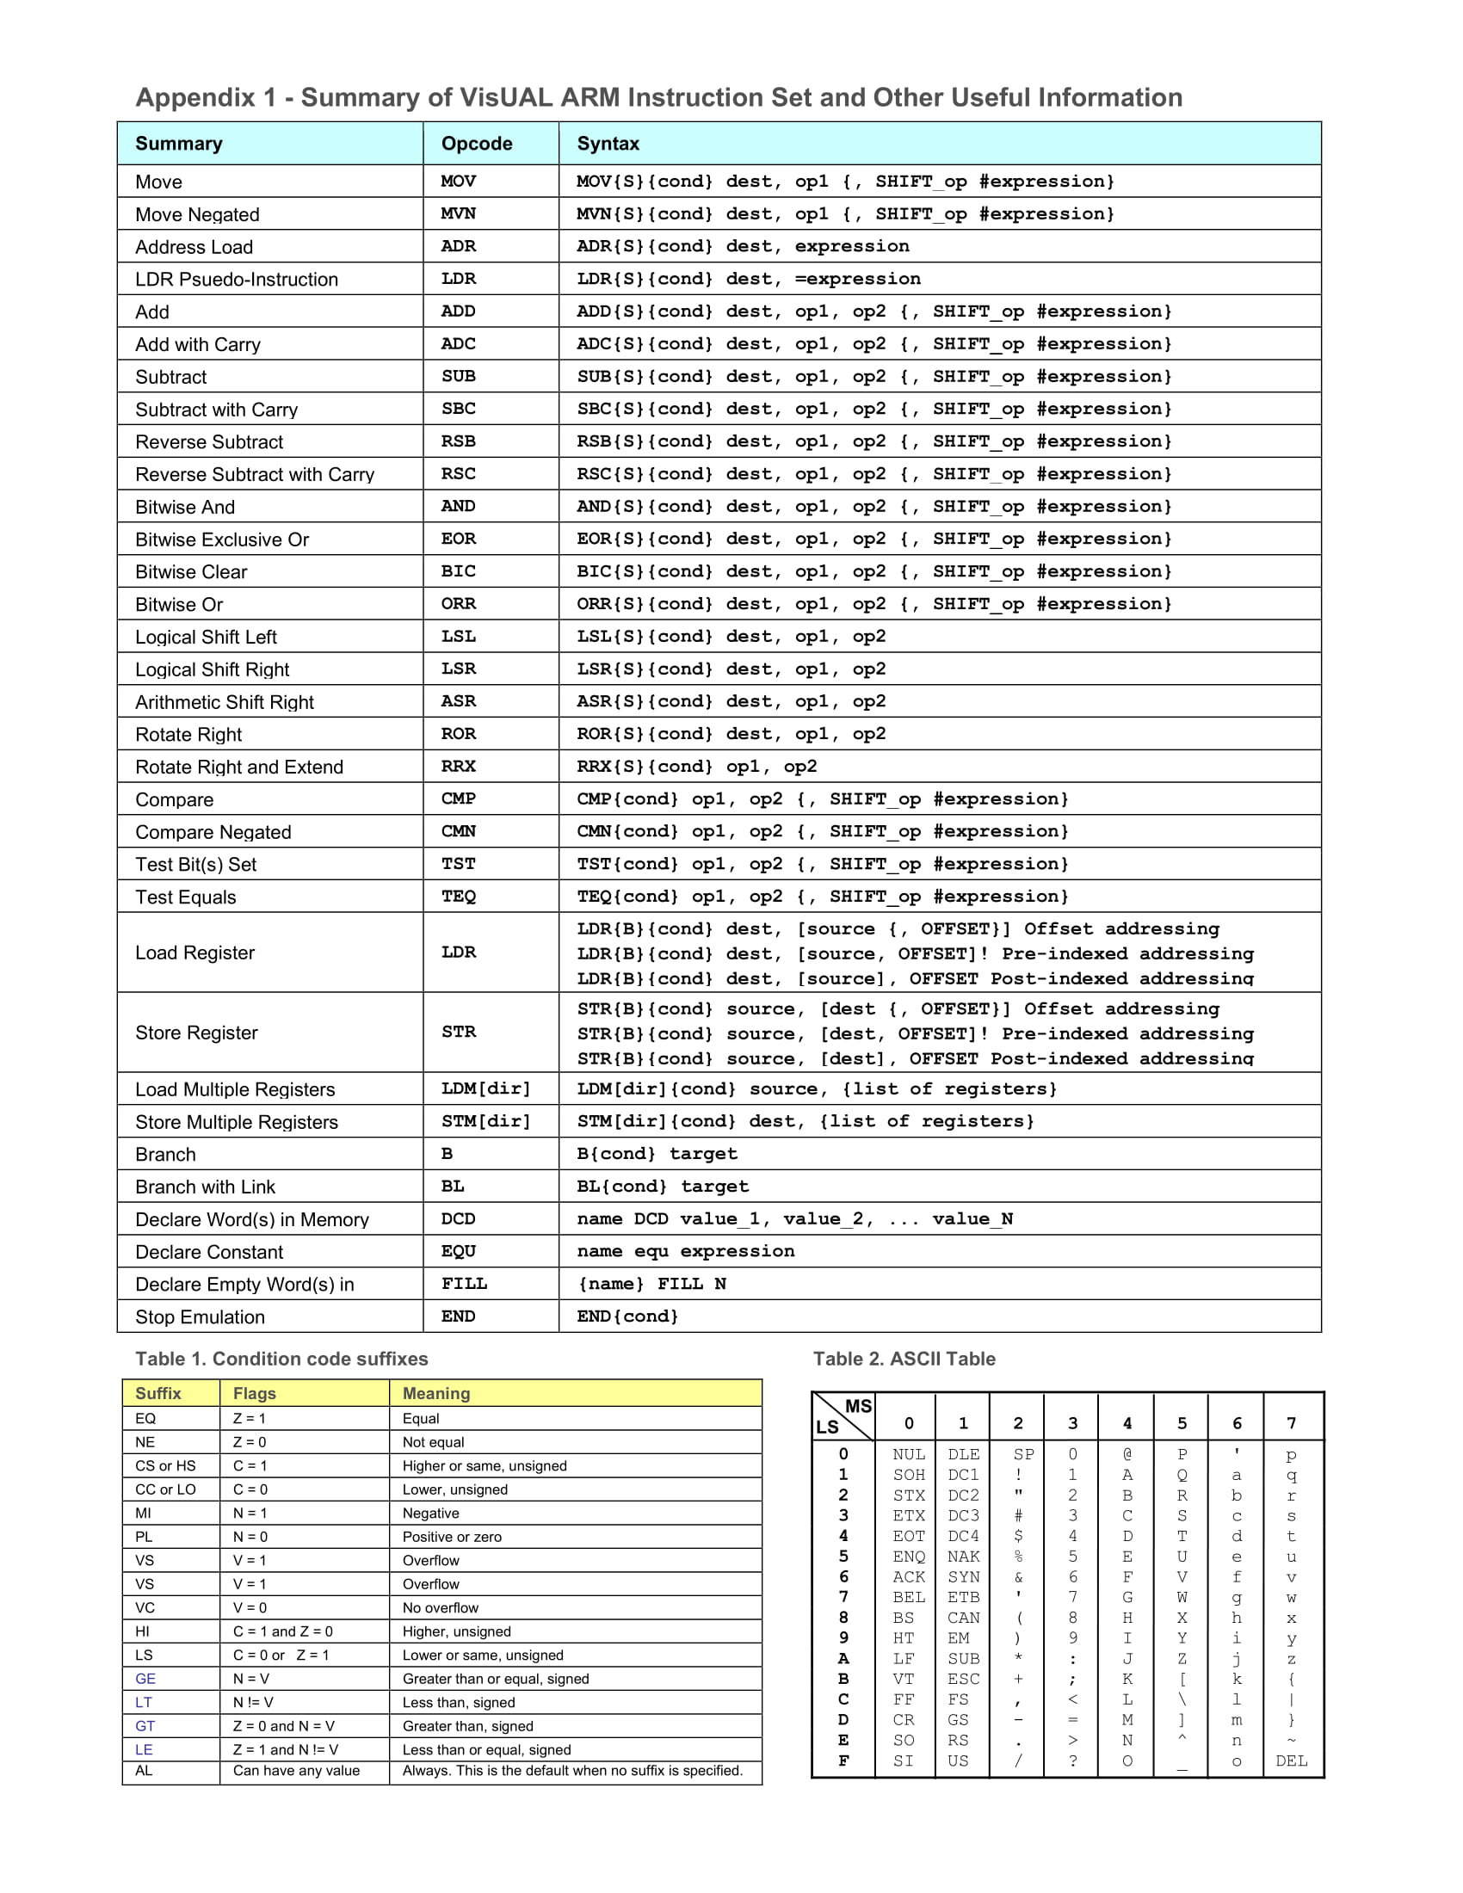

Part 2: Hardware

Chapter 1: Computer Systems Overview

1.1 Signal Chain Subsystem
- ADC - DAC
- Parallel & Serial Digital Interfaces
- Interrupt Controller
- Direct Memory Access Controller (DMAC)

Interacting to the real-world
Analog ⇒ Continuous signals | Digital ⇒ Discrete signals with steps
Continuous in voltage and time domain | Discrete voltage levels, discrete time representation of analog signal
Digital Quantization ⇒ Analog signal mapped to a discrete representation using bits

1.2 Electrical Signal Interface
Interface
Boundary where 2 or more devices meet to exchange information

Connection Type - Interface to outside world via pins. Pins can be:
Input | Output | Bi-direction

2 modes of connection
Parallel ⇒ Multiple bits transferred simultaneously | Serial ⇒ Single bit transferred at one time

Interface Compatibility - Electrical Signal Level
- Ensure output voltage level does not exceed maximum input voltage level of other device
- Check voltage level which device in/output is operating on (1.8/3/5/15V)

4 Parameters:
VOH  Logic ‘1’ >= VOH | VOL  Logic ‘0’ <= VOL | VIH  Logic ‘1’ >= VIH | VIL  Logic ‘0’ =< VIL

Differential Signals
Higher noise tolerance and is able to be clocked at a higher frequency
Communication Protocols
How the data is formatted; number of bits in transmission frame, synchronization, data width, type of data & formatting etc.

1.3 Parallel Data Transfer
Definition ⇒ Multiple bits of data simultaneously transferred; is synchronous as a strobe signal is needed to inform the receiver when to latch in the data.
Pros | Cons
- Faster data transfer  - Hardware design simpler as only strobe signals needed | - Affected by signal skew & Cross Talk  - Limits max. clock speed and distance  - Hardware bulky if data width large  - Needs more space for PCB trace routes  - Higher hardware cost

Signal Skew
- Signal between different data lines take different amount of time to reach receiver
- Results in wrong data being latched by receiver
- Contributed by:
  - Variation in propagation delay → time taken for signal to travel between 2 pts
  - Capacitance & Resistance of physical data line. Larger resistance & capacitance → larger delay
  - Variation in PCB trace length & width. Fixed by looping & ensuring PCB trace lengths equal & equally spaced apart

Cross Talk
- Undesired coupling of signals from one circuit to another circuit
- Can be transmitted electrically or via electromagnetic radiation
- Contributed by:
  - Close placement of PCB lines

1.4 Serial Data Transfer
Definition ⇒ Data transferred one bit at a time
Pros | Cons
- Less affected by signal skew, fewer electrical wires involved  - More reliable data transfer over long distance  - Lower cost; fewer wires & connectors | - Lower data transfer rate  - Hardware interface more complex, needs to handle serial to parallel conversion

Serial Data Transfer Modes
Simplex ⇒ One direction only | Half-Duplex ⇒ Bi-directional but one at a time | Full-Duplex ⇒ Simultaneous transfer both directions
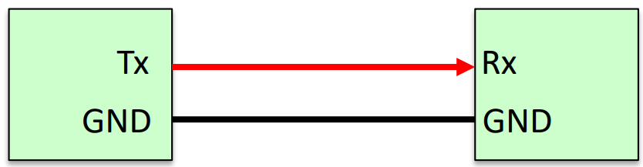 | 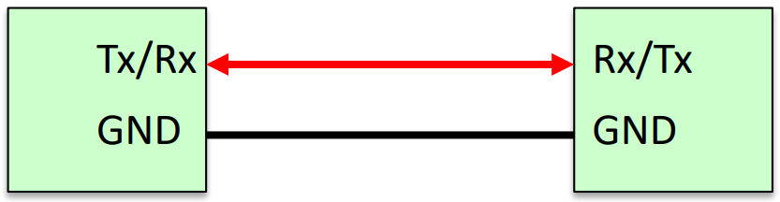 | 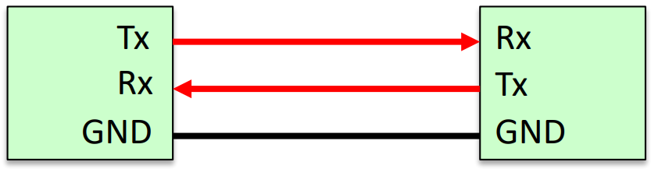

Synchronous vs Asynchronous
Synchronous | Asynchronous
- Common clock signal  - Synchronizes data transfer  - Master-slave configuration; master provides clock signal  - Potentially allows faster transfer as no overhead for synchronization | - NO common clock signal  - Agree on pre-fixed clock frequency
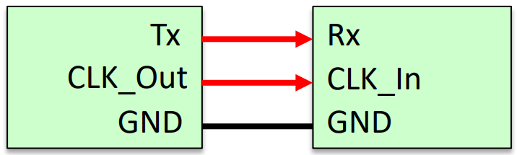 | 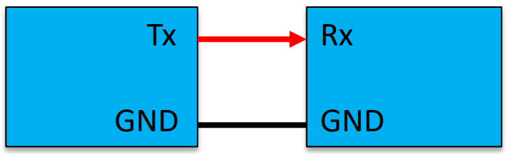

I2C SPI Bus ⇒ Transfer data & control to many peripheral devices

Serial Peripheral Bus
- Slave Select pulled low → to start transfer
- Data on MOSI/MISO latched in on rising/falling edge
  - MOSI → Master Out Slave In (Master output, slave input)
  - MISO → Master In Slave Out (Master input, slave output)
- Multiple slaves via multiple Slave Select

1.5 Direct Memory Access
Optimizing CPU Resources in Data Transfer
- CPU being used to perform data transfer is inefficient
- DMA Controller (DMAC) is added to relieve CPU of data transfer tasks
- No Conflict in Hardware resources → data transfer via DMA and CPU can happen simultaneously
- Conflict in Hardware resources → priority given to higher priority; which is configurable and is processor-specific

DMA Controller (DMAC)
- Data Bus Controller that performs data transfer independent of CPU
- Located between:
  - Memory/Memory, IO Peripheral/IO Peripheral, Memory/IO Peripheral
- Generates Address, initiates Read/Write operations between devices

Basic DMA Process
- DMA Configuration Initialization by CPU to DMAC
  - Source Address
  - Dest Address
  - Amount of Data to Transfer
  - DMA trigger signal (DMAREQ, interrupt, software bit etc.)
- CPU Proceeds with own task while DMAC waits for DMA Trigger Signal
- On DMA Trigger, DMAC request to take over system bus
- DMAC transfer data according to configuration
- DMAC notify CPU of completion (typically via interrupt), releases system bus

DMA Modes of Operation
Burst ⇒ DMAC gains control of bus and transfers multiple units of data before returning CPU
- Burst could be entire block of data or subset of block
- CPU may be suspended till DMAC completes data transfer if it needs data bus
- Faster rate, but may cause extended CPU inactive time
Cycle Stealing ⇒ DMAC release data bus after transferring one unit of data
- Tends to execute between CPU instructions or between pipeline stages
- CPU may be suspended but suspend time is shorter should it need data bus
- Slower than Burst Mode, but reduces CPU inactivity
- Favored in applications requiring high CPU responsiveness
Transparent ⇒ DMAC transfer only when CPU not using data bus
- No impact to CPU performance
- Potentially slowest transfer rate
- More complex hardware to detect when CPU not using data bus
- Could also be used as a cue to trigger burst transfer when CPU not using system bus

1.6 Asynchronous Data Transfer
Definition ⇒ No common clock provided between transmitter and receiver.
- Receiver needs to know clock rate and number of bits before transfer
- Special SYNC words used to indicate START/STOP
- Receiver uses own clock upon receiving START
- Potential skew between 2 local clocks
- Also uses SYNC word/bits to provide occasional timestamps for resynchronization

Universal Asynchronous Receiver Transmitter (UART) - Transmission Process
- IDLE ⇒ Data line in ‘powered’ state (logic ‘1’)
- START ⇒ Sent by transmitter (logic ‘0’) to alert receiver
- DATA ⇒ Actual data transmitted at frequency known to the receiver
  - Baud Rate → Transmitting clock rate; bits transferred per second
- PARITY ⇒ Optional, checks integrity for data packet
- STOP ⇒ Logic ‘1’ to terminate transmission

Parity Bit
- Even ⇒ Even number of ‘1’s transmitted in data+parity field
- Odd ⇒ Odd number of ‘1’s transmitted in data+parity field
- Checks for parity error, does not perform correction
- Receiver samples STOP bits, if ‘0’ received → Framing Error

UART Transfer Example
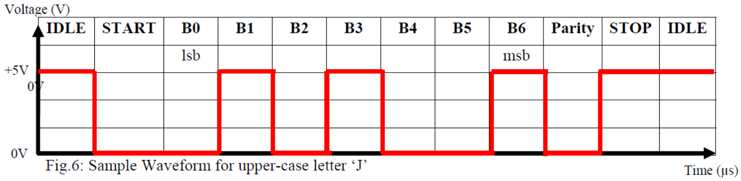
- Configuration: 7O1 (7 bits of data, O for odd parity, 1 bit for STOP)
- In this example capital letter ‘J’ being transmitted (0x4A, 100 1010)
- NOTE: LSB is presented first

UART Receive
- Falling edge trigger interrupt to start receiving process
- Baud Rate must be known

Differing Baud Rate Example
100 1010b ⇒ At 1x baud rate | 0011000b ⇒ At 2x baud rate, each bit x2
 | Note: LSB’s 0 → 00, one bit taken by START

1.7a Data Transfer Mechanism - Polling
Definition⇒ CPU polls I/O port continuously using software for data or readiness of port to perform data transaction
Pros | Cons
- Programmer has complete control over entire process  - Easiest method to test & debug | - CPU waits in loop, cannot perform any other task  - Inefficient use of CPU resources

Polling Technique
- CPU performs all necessary initialization
- CPU Polls I/O device for readiness for data transfer
- I/O device not ready → CPU continues wait in loop to check if device ready (Back to 2)
- Device Ready → CPU make data transfer & exits loop

1.7b Data Transfer Mechanism - Interrupt
Definition ⇒ Signalling mechanism that allows peripherals to alert CPU that attention is needed
Pros | Cons
- Efficient use of CPU resources, do not need to monitor peripheral readiness  - CPU continue on its own task between interrupts  - Allows prioritization & pre-emption | - More hardware & circuitry needed between I/O device & processor  - Program slightly more complex & difficult to debug

Interrupt Flow
- Signal alerts CPU that attention is required
- CPU receives signal (interrupt request) decide if wants to service request
- Service → CPU follows up wit series of procedures to handle interrupt event

Interrupt Vector Table
- Starting Address of each interrupt (Interrupt Service Routine) is stored in interrupt vector table
- Each interrupt has unique index to vector table

Interrupt Control Flow
- Signal/change in status in special registers notifies CPU that attention needed
- CPU choose to service
  - Suspend current program
  - Look up interrupt vector from vector
  - Save copy of processor context
  - Execute interrupt, and restore processor context when done
Interrupt Service Routine (ISR)
- Performs some operation like data transfer
- typically short routine to not suspend CPU for too long
- CPU returns to previous program & continue from where it branched off after servicing ISR
- Possible for CPU to receive multiple interrupt requests simultaneously → Use arbitration scheme to determine priority

Chapter 2: Computer Memory

2.1 Computer Memory Introduction
Memory Cost/Function Tradeoff
- Faster access time → more expensive

2 Types of Memory
VOLATILE | NON-VOLATILE
- Data lost when power removed  - System Memory e.g. RAM | - Data retained when power removed  - Permanent Storage e.g. FLASH

2.2a Semiconductor Memories (Volatile)
Definition
Memories made based on semiconductor integrated circuits.

Random Access Memory (RAM)
Static | Dynamic
- Data stored as long as supply applied  - Large (4 to 6 transistors per cell)  - Fast  - Low Power Consumption | - Periodic refresh needed  - Small (1 to 3 transistors per cell)  - Slower  - Higher Power Consumption due to periodic refresh to maintain data integrity

SRAM Cell
- Organised in arrays (Rows)  - Accessed via word & bit lines  - 6 transistors per cell  - Actual data placed on differential bit lines, connected to data bus  - Data bit stored in M1,2,3,4 and M5,6 pass transistors | 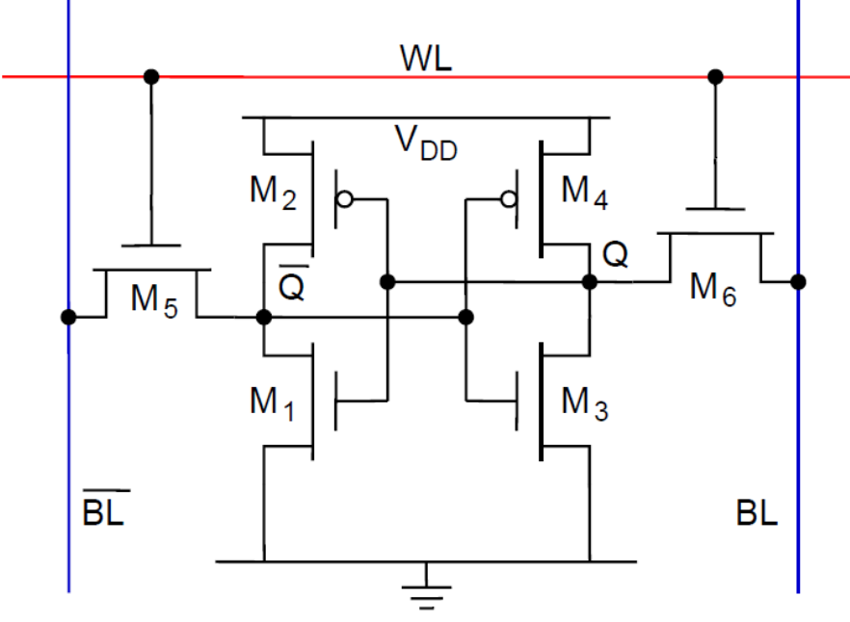
Dynamic RAM Cell
- Single transistor  - Uses Capacitor as storage element  - Transistor controls charges flowing in & out  - Write Process → Enable transistor and  - Logic 1 → transfer charge into capacitor  - Logic 0 → discharge capacitor  - Read → Enable transistor & measure capacitor charge using sense amplifier | 
Maintaining Data Integrity in DRAM
- Read process destroys information, measuring charge also discharges capacitor
- Original data must be re-written back
- Periodic refresh needed as charge ‘leaks’ over time
Synchronous DRAM (SDRAM)
- Basic DRAM obsolete. SDRAM uses clock signal to synchronize data transfer for faster transfer rate
- Also has pipeline architecture for overlapping & faster operations
- Double date rate → faster speed

2.2b Semiconductor Memories (Non-volatile)
EPROM & EEPROM → Floating Gate Transistors
EPROM → Erasable Programmable ROM | EEPROM → Electrically Erasable Prog. ROM
To erase stored program, put under UV light | - Reduce oxide thickness  - Can electrically program & erase

MOSFET → Metal Oxide Semiconductor Field Effect Transistor
- Gate Source Voltage (V_{gs}) > Threshold Voltage (V_{t}) → Current flows from source to drain
Floating Gate Transistor → Like MOSFET but with extra layer
- Programming results in altered threshold voltage (V_{t}) of the FGT
- Program → charge injected, and voltage removed leave charge trapped, causing higher voltage threshold when programmed
Reading Stored Data in Floating Gate
Transistor OFF → floating gate programmed & contain charges | Transistor ON → floating gate erased (no charges)
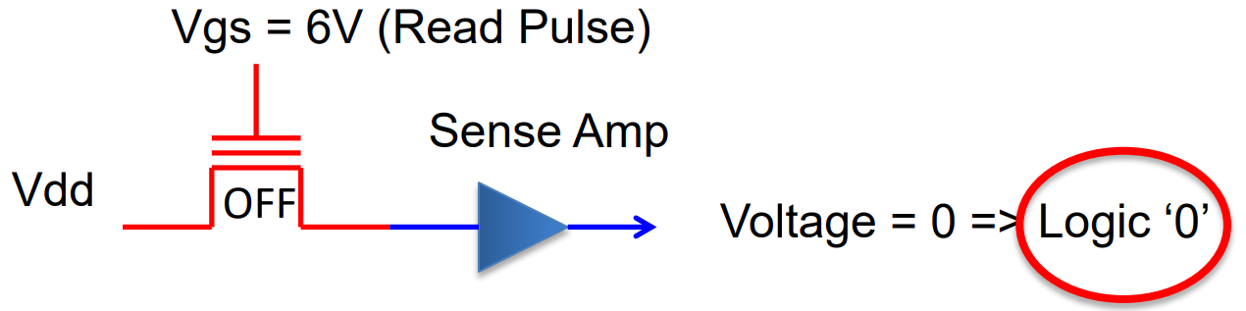 | 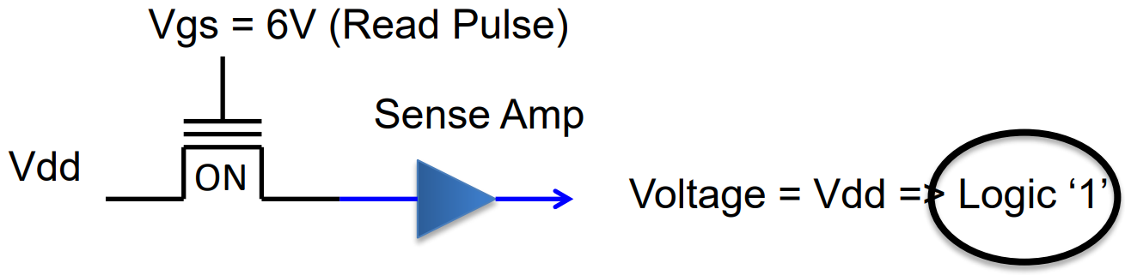

Example of Programming using FGT based memory
- Flash programming can modify cell content from ‘1’ to ‘0’
- Modify cell content from ‘0’ to ‘1’ erase must be done at block level

2.2c Semiconductor Memories (Non-Volatile -- FLASH)
Definition
- Based on same FGT as EEPROM
- Can be erased in larger block size compared to EEPROM
- Flash has faster speed when performing write for large blocks of data
  - BUT slower for erase cycle
- Less cost than EEPROM, suitable for system needing large amounts of non-volatile memory

2 Types of FLASH
NOR  (Used as system memory) | NAND  (Used as storage for SSD)
- Cell behaves like NOR gate, any Word Line > Vt → Bit line output = 0  - Support execute in place, program stored in parallel can execute w/o transfer to internal RAM  - Random reading of memory data using address info  - Special commands required to perform operations other than reading  - Allow random byte/word programming, erasure done at block level  - Use as system memory to store program code/general storage memory | - Cell behaves like NAND gate, ALL word line > Vt(prog) → output = ‘0’  - No execute in place  - Data access one page at a time  - Command opens particular page, followed by bytes needed in the page  - NAND chips use single bus to carry address & daa  - Lower cost per bit than NOR, used as main storage memory
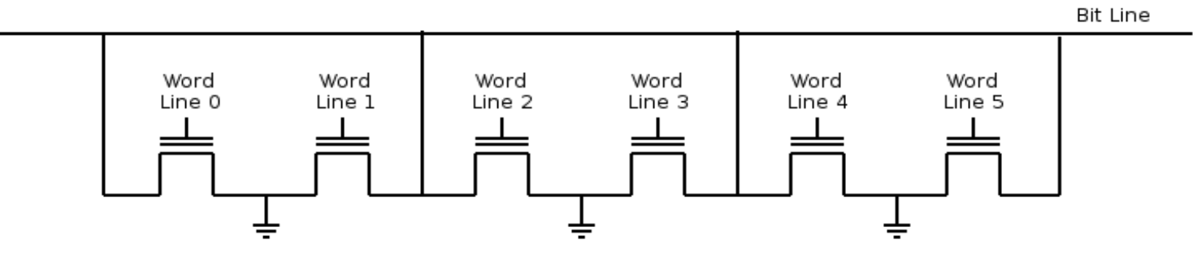 | 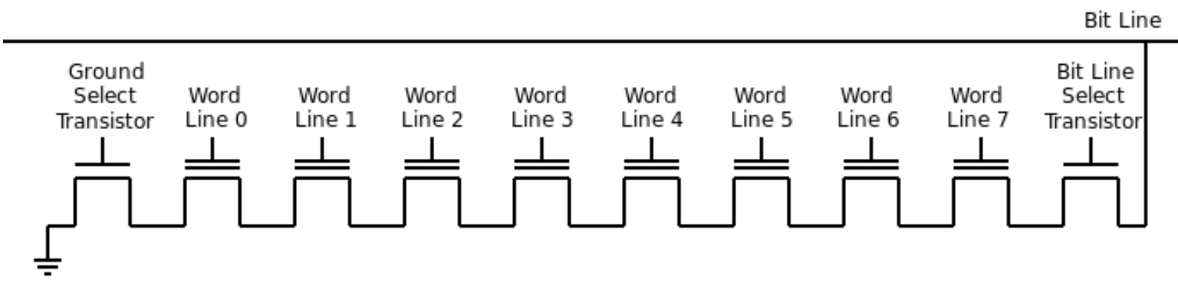

System vs Storage Memory
System | Storage
- Store runtime program  - Refers to SRAM/DRAM or NOR flash | - Store program & data in computer  - Cannot run code directly from memory, must be transferred to system memory before execution  - All memory types can be used as storage memory

2.3a HDD & SSD (HDD)
Magnetic Hard Disk
- Stores data by magnetizing thin film of ferromagnetic media on circular disc(platter)
- Magnetic head uses wind pressure generated by speed of disk rotation to fly above surface
- Fly height very small (smaller than fingerprint)

Magnetic HDD Data Organisation
- Data stored in ‘ring’s on platter called tracks  - Tracks divided into sectors  - Minimum data block size is a sector  - Stored data includes  - header  - data  - trailer | 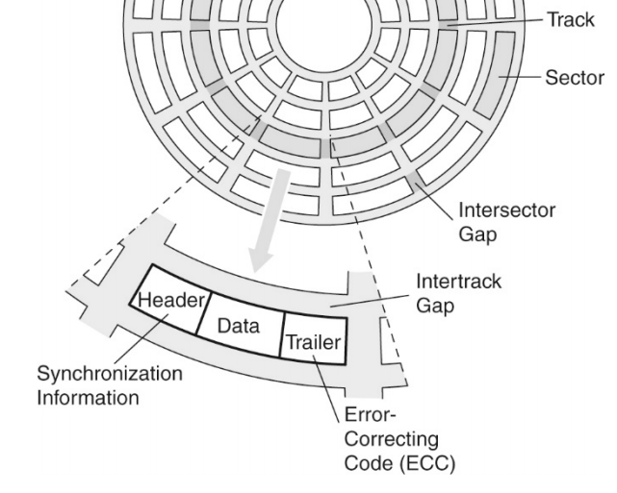

Transfer Rates
Seek Time (T_{S})  - Time taken for head to move to correct track  Rotational Delay (T_{R})  - Time taken for disc to rotate till head reaches target sector  Access Time (T_{A})  - Time from request till time head is in position (T_{S} + T_{R})  Transfer Time (T_{T})  - Time needed to transfer data after head positioned | 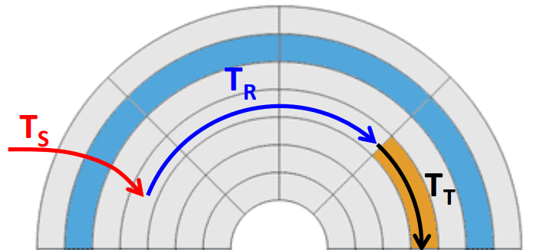

HDD Transfer Rate
T_{R} dependent on rotational speed (RPM typically converted to RPS = RPM/60) Random section, avg rotational delay ⇒ | 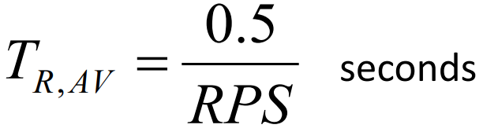
T_{T} dependent on rotational speed (RPS), track density(D_{T}), sector density (D_{S}) (number of sectors per track & bytes per sector), and number of bytes N for transfer | 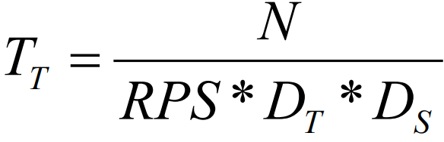

Physical Layouts of HDDs
EARLY  - Equal number of sectors per track  - Each sector has same data size  - Simplify controller design  - Inefficient usage of real-estate | 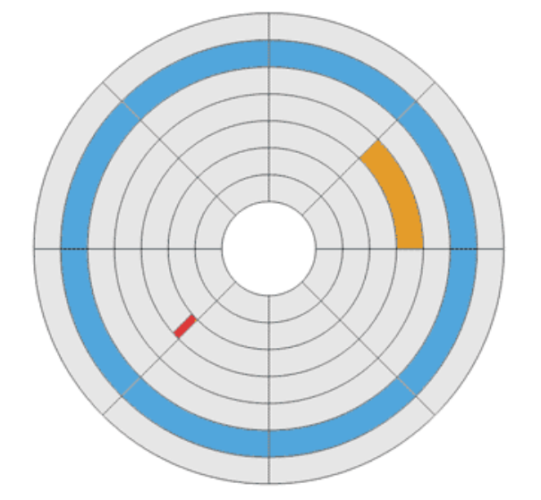
MODERN  - Zone bit recording technique  - Tracks divided into zones  - Zones have differing no of sectors per track | 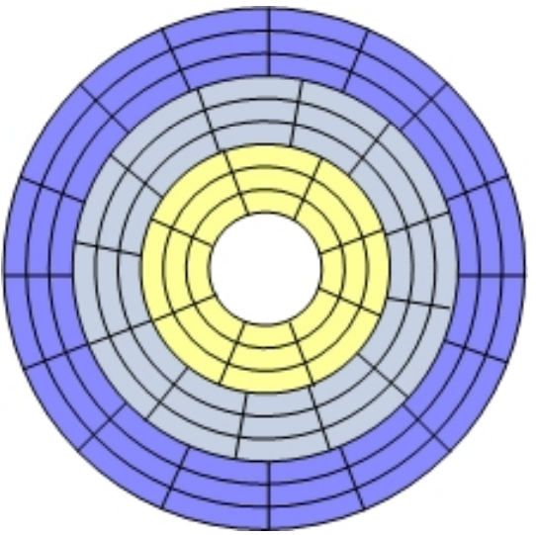

Modern Day HDD
- Actuator ARM fixed, access must be sequential; data split → wait for 1 disc revolution
- Seeking track to track takes time
- More efficient to read in blocks
- Vulnerable to motion

2.3b Solid State Drives (SSD)
Definition
- Memory array based on NAND or NOR Flash
- Limited program-erase cycles (3K to 1M)

Extending Life of SSD
- Wear Levelling → distributes data erase/write operations evenly over entire disc
- Use External RAM → as buffer to minimize number of writes to flash in SSD
- Error Correction Code → Ability to recover from one or more bits of error in media

OVERALL COMPARISON
 | HDD | SSD (NAND Flash)
PROS | - Lower cost per bit  - Almost infinite erasure cycle | - No moving part, robust to movement  - Lighter, occupies less space  - Higher transfer rate
CONS | - Moving parts prone to crashing if HDD shaken/dropped  - Heavier & larger physically  - Slower transfer rate | - More costly  - Finite number of erasure cycle

2.3c Data Center Storage & HMAR
Criterias
- Power Consumption → Data centres need a lot of power
- Speed → Caching databases or other data
- Robustness → Tolerance to various form of mechanical modement/interference
- Heat Production → Less heat, less power needed
- Size → Store more data in less space
- SSD better than HDD, but data centres COST is a issue, so HDDs are still Dominant

HMAR (Heat Assisted Magnetic Recording)
- Laser heats tiny spot on disc where data to be written  - Smaller bit cell can be written as 1 or 0  - Close data packing a problem on conventional HDDs, magnetic field may interfere other bits  - Recording media must have higher coercivity  - More magnetically stable but difficult to change when writing  - Resolved using laser to heat tiny spot for short time  - Written when area hot  - Medium cools down after & data is frozen in place | 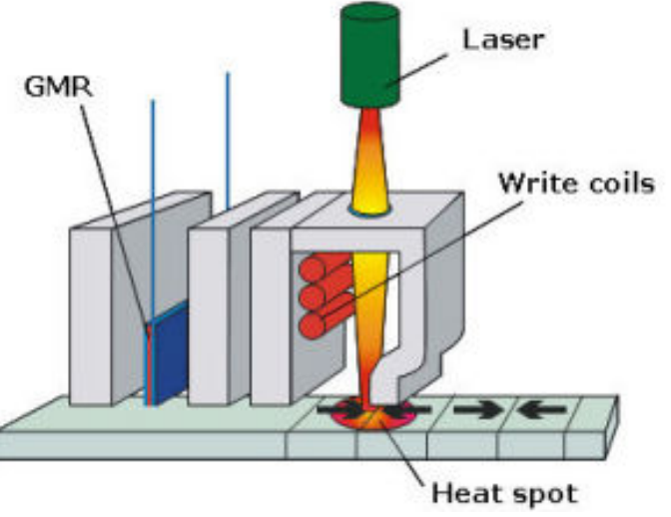

Chapter 3: Cache & Virtual Memory

3.1 Cache
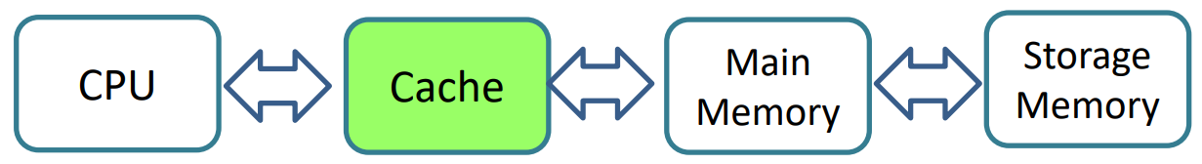
- Issue: CPU speed much faster than external memory
- Need: Fast memory to act as buffer between main memory and CPU
- Purpose: Store/Fetch recently used data to speed up access
- Improves overall system performance

CPU memory access
- To access data CPU send request to nearest memory i.e. cache
- Data not in cache → Request to main memory
- Data not in main memory → Send request to storage memory
- Data located → required data & some of its nearby data elements fetched into cache memory simultaneously

Principle of Locality
- Once a byte in a program is accessed, nearby data element will be needed soon
- Locality of Space
  - Code/Data nearby each other & likely to be accessed together
- Locality of time
  - Recently accessed code/data is more likely to be accessed again

Cache Memory Replacement Policy
- If need to transfer a block of data but cache is full, need to decide which existing block to evict/purge to free up space for new data
- Last Recently Used (LRU) keep track of last time block accessed, evicts one unused for most period of time
  - Complex; need to keep track of access history; slows down cache
- First-In, First-Out (FIFO) i.e. like a queue is popular, block in cache for longest is removed regardless of when it was last used

Cache Mapping Scheme
- Deals with how each memory block is mapped to a cache block.
- 3 Basic cache Mapping schemes → Direct Mapped, Set Associative, Fully Associative
- Terms
  - Blocks → Cache divided into smaller storage locations (aka cache lines)
  - Whole cache block is transferred when one of more bytes in the block are needed

Cache Mapping Scheme -- Direct Mapped
- Each block in memory can go into one cache block location  - N blocks of Cache, block X of main memory maps to: Y = X mod N  - Whole block of data filled if at least 1 byte in block needed  - Tag value keeps track of which main memory block associated with each cache block | 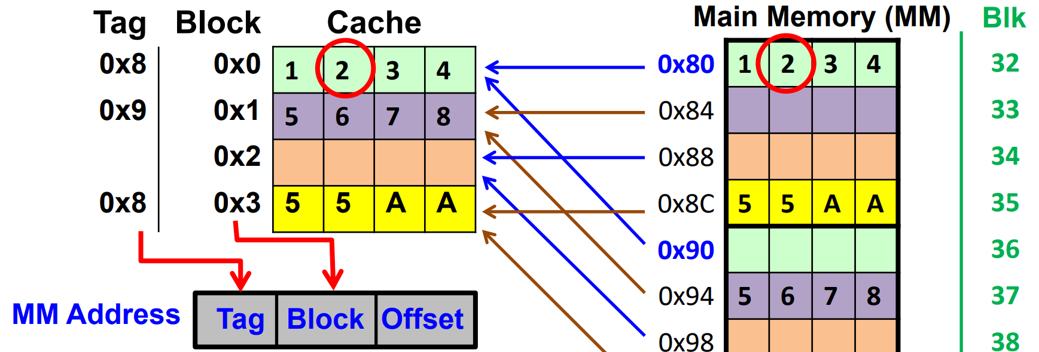  Note: The tag corresponds to first hex of the main memory  Address is Y = X Mod N

Elaboration on basic principle
- Cache mapping allocates data in entire system memory into cache
- Able to uniquely identify every system memory location
- Uses fact that system memory addresses are unique

Data Address Structuring
- Number of bits allocated to each field depends on structure of cache
- OFFSET → data’s offset from start of the cache block
- BLOCK → Index of the cache block that targeted data will be mapped to
- TAG → Remaining bits that are left over of the system memory address
- EXAMPLE: 0x81 ⇒ 1000 00 01 ⇒ Tag is 0x8, Block ix 0x0, offset is 0x1

Data Retrieval Example
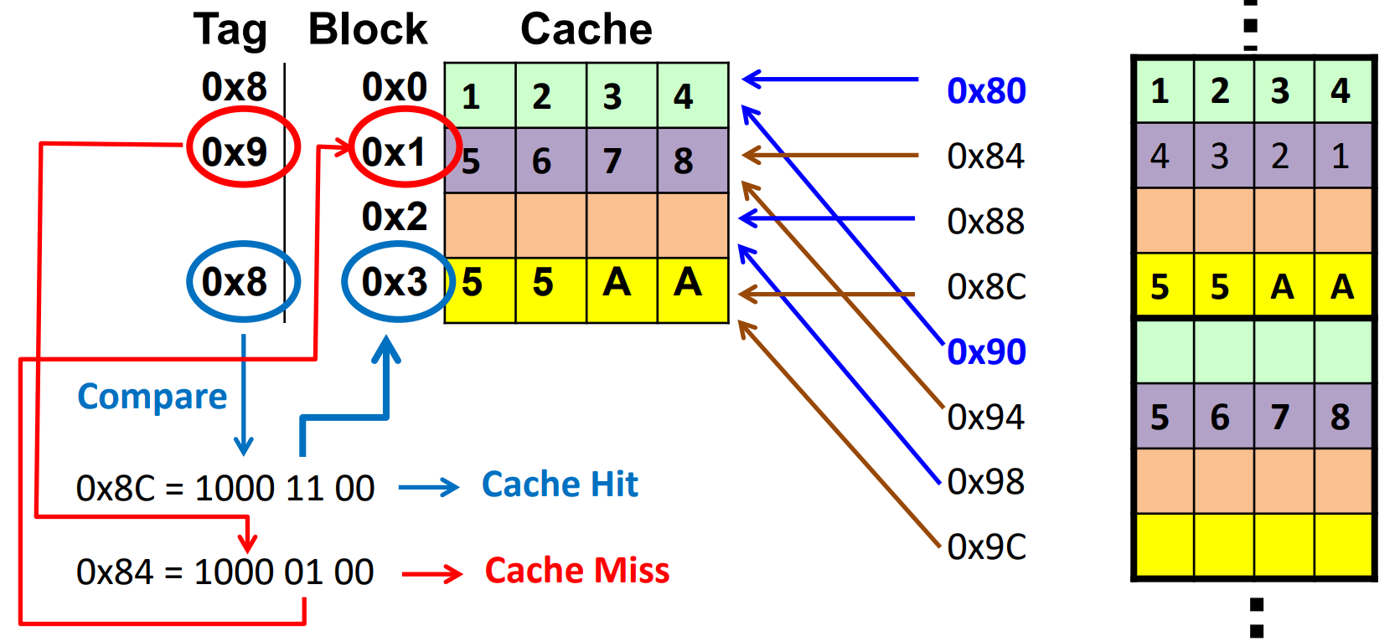

Cache Write Policy
- Dirty Blocks → Locations written into cache by CPU
- Cache replacement policy must account for dirty block to prevent loss of data
- Dirty blocks must be written back into memory, determined by write policy

Write Policies
WRITE HIT
Write Through  Updates cache and main memory simultaneously at every write | Write Back  Updates memory only when block is selected for replacement
WRITE MISS
Write Allocate  Fetch on write. Write miss will cause data block to be loaded to the cache | Write no allocate  Write miss wont load data onto cache. Written directly to location on main memory

Cache Performance Related Terminologies
- Cache Hit → Data found in cache
- Cache Miss → Data not in cache
- Cache Hit Rate (H) → % of time data is found in cache
- Cache Miss Rate → %of time data not found in cache (1-H)

Effective Access Time
- Weighted acreage taking into account hit ratio & relative access times
  - EAT = H * AccessTimeForCache + (1-H) * MissPenalty
- Assuming data access to cache & main memory do not overlap
  - MissPenalty = AccessTimeForCache + AccessTimeForMainMemory
  - EAT = H * (AccessTimeForCache) + (1-H) * (AccessTimeForCache + AccessTimeForMainMemory)

3.2 Virtual Memory
Basic Concepts
- Address space is range of discrete addresses
- Every piece of data/code assigned address by compiler
- Executing program → information required is obtained by issuing request to OS using addresses assigned by compiler
- OS is the middle man translating compiler generated address to system memory address

Virtual Memory Management
- Every program has own Virtual Address Space
- Actual program code & data stored in system & storage memory
- Address translation done by OS

Virtual vs Physical Memory Address Space
- Virtual memory generated by compiler → Virtual Address
- Typically different from physical memory address
Advantages of Virtual Memory
- OS can isolate virtual memory space → prevents corruption
- Efficient & safe sharing between programs within shared system memory
- Enables more than one program to run simultaneously even if size of programs larger than physical memory size
- OS can relocate virtual memory blocks to physical memory blocks → appears continuous to virtual memory but actually fragmented in disc
Address Mapping
- 2 common schemes
- Paging (Only focus on this)
- Segmentation

Address Mapping - Paging
- Memory space partitioned into fixed sized blocks called page/frame
- Page table → Contains information concerning location of each page
- In the page table:
  - Frame → physical frame no in physical memory
  - Page → virtual page number used by program code
  - Valid Bit (VB) → indicate if virtual page in main memory 1 = yet

Address Translation
- Always work in binary number format
- Offset remain unchanged
- Virtual page number replaced with physical frame number
- Ensure valid bit = ‘1’

Paging Example
0x1553 = 1010101010011b  - Data resides in virtual page 5  - From page table, page 5 is mapped to physical frame 1 and valid bit is 1  - Physical Address: 010101010011b ⇒ 0x0553  0x0FA0 = 0111110100000b  - Data resides in virtual page 3  - From page table Valid Bit is 0  - Data not in physical memory → Page Fault  **Width of the bits for each part is dependent on size of physical mem & page size etc.** | 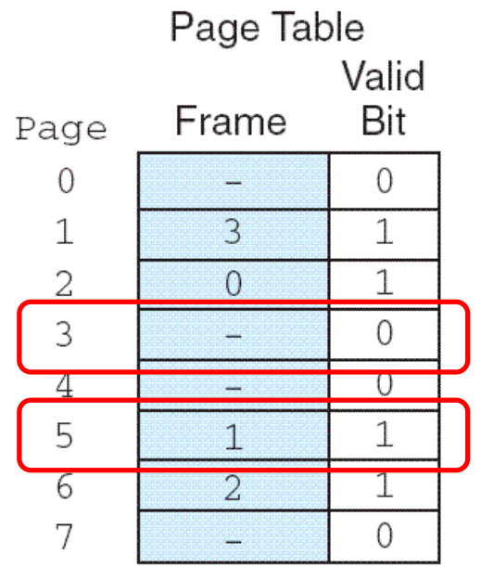

Translation Lookaside Buffer (TLB)
- Page table in main memory, access relatively slower than internal memory access
- Page table cache used to speed up page translation process
- TLB implemented with fast memory like SRAM resides in the processor
- Each TLB includes virtual page number and corresponding frame number

Chapter 4: Communication & User Interface

4.1 Universal Serial Bus
- Standardize connection of computer peripheral devices
- Replaced many interface buses

USB Topology & Interface
- All data transactions initiated by USB host
- Host assign address to devices connected
- Data transaction in respect to USB host
  - Data going into host → IN
  - Data going out of host → OUT
- Power supplied by
  - Host/Hub → Bus Powered
  - Own power source → Self Powered

USB Enumeration & Device Class
- Enumeration process when USB first connect
- USB & Host exchange information on compatibility & requirement
- Host cannot communicate with device till enumerated
- After Enumeration → Host check if has driver to support USB
- USB Device Classes
  - Human Interface Device → Mouse, Keyboard
  - Communication Device Class → Arduino
  - Mass Storage Class → interface to external HDD/SSD
  - Audio Class → Audio to USB headset/mic

High Definition Multimedia Interface (HDMI)
- Proprietary to transmit uncompressed video data & uncompressed digital audio data
- Consumer Electronics Control (CEC) allows HDMI devices to control each other

Industrial, Scientific & Medical (ISM) RF Band
- Range of ‘Royalty Free’ radio frequency bandwidths
- 2 Common worldwide ISM band is 2.4 Ghz & 5.8 Ghz

Wifi
- Family of wireless networking technologies
- Operates in 2.4 & 5.8Ghz RF range
- Transmission range between 20 to 150m
- Up to 10Gbps
Infrastructure Topology  Star topology, center of network is access point/router connected to devices at end | Ad-hoc Topology  Peer to peer connection
Bluetooth
- Low data rate wireless transmission, focus on low power consumption
- 2.4 Ghz range
- Transmission up to 100m, kept 10-20m to keep low power consumption
- Star topology
- Kbps and Mbps
- 2 different protocols → Standard & Low Energy

Factors affecting transfer rate
- Transmission power → higher power higher range
- Frequency → Higher frequency, higher attenuation (amplitude decays faster)
- Interference → Many standards work in same 2.4 band, transmission will interfere with each other

Mitigating Interference
- 2.4GHz band divided into sub-bands called ‘channels’
- Select different channels to use from neighbors
- Frequency Hopping → constantly hop between channels used by bluetooth

Keyboard
- Microcontroller on board detect key press & sends corresponding ASCII Codes to computer
- Wired Keyboard use USB interface, wireless operate in 2.4 GHz

Mouse
- Reports (x,y) coordinates and left/right mouse button
- Information periodically reported back to PC
- Higher scan rate → higher response

Capacitive Touch Interface
- Seen as a capacitor to the processor it is connected to
- Conductive element present (finger) effective capacitance increase
- Calibration done under assumption of human finger touch

Capacitive Touch Screen
- Array of electrodes as capacitive touch sensors
- Finger touch any part of screen affects one or more electrodes, closest has more change to capacitance
- Controller used to process information of exact point of contact

Camera
- Lens → Looks into real world
- Image Sensor → transduce photons (light info) to electrical signals (analog)
- Image Signal Processor → handle image processing of image data from processor
Microphone
- Uses variation in capacitance when diaphragm is displaced by sound pressure to transduce sound wav to electrical signals
- ECM → electrical charge needed measure change in capacitance
- MEMS → electrical charges provided by charge pump

LCD Basics
- Passive display technology, does not emit light, relies on backlight to see image
- Liquid crystal has both liquid & crystal molecular structure. Rod shaped molecules keep order in particular direction despite being in liquid
- Molecules twist light passing through them
- Amount of light passes through depends on crystal orientation with respect to polariser
- Results in light passing/being blocked from point of view

Color LCD
- Each pixel has 3 color filters to project RGB colors
- Varying orientation of molecules in liquid crystal varies amount of light passing through each filter
- Changes the color that is displayed

Audio Speaker
- Transduces electrical to sound energy
- Speaker core vibrates, push & pull air to create sound waves
- Conversion uses electromagnetic coil and magnet combination attached to core

Chapter 5: Processor Pipeline

5.1: Overview of Simple CPU
- Simple CPU uses 3 operations sequentially: Fetch → Decode → Execute
- Simple CPU all 3 operations must complete before next instruction fetched
- Executing each instruction one a time takes more cycles, longer to execute
Simple CPU | With Pipeline Architecture
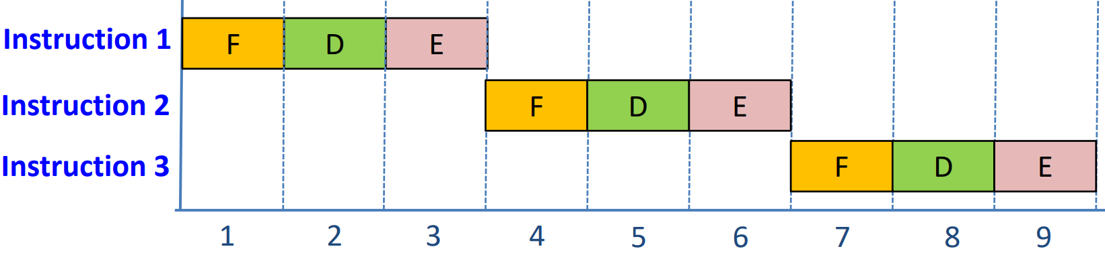 | 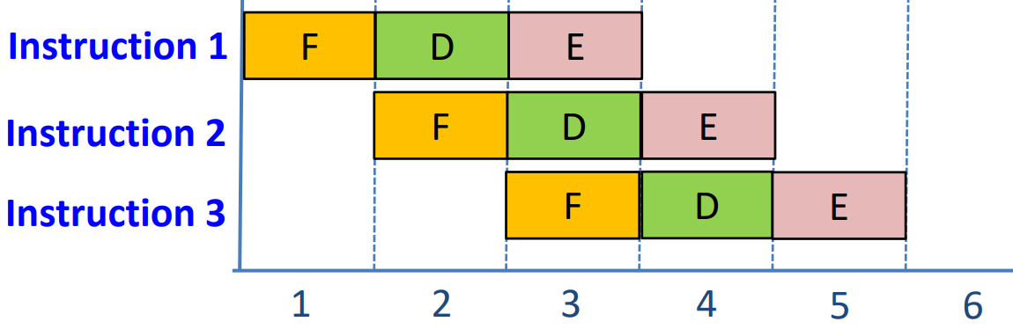

Pipeline Architecture
- Partitioning instruction into simpler stages
- Assign resources to allow stages to be executed simultaneously
- Possible if Fetch-Decode-Execute operations use independent resources

Pipeline Efficiency
- Efficiency maximized when pipeline is filled
- E.g. 4 stage pipeline processor
  - Fetch, Decode, Execute, Data Store
- Takes 4 cycles to fill pipeline & release first instruction from pipeline
- After pipeline filled, release one instruction every cycle

Pipeline Conflict
- Pipeline efficiency reduced if disruption to the pipeline
- Events that disrupt pipeline → pipeline conflict
- Cause temporary halt to pipeline, processor may need to flush instructions & reload with fresh set of instructions

Sources of Pipeline Conflicts
Cause | Resolution
Resource Conflict ⇒ when 2 instructions attempt to access same resource in cycle  e.g. storing result in memory + fetching another instruction | Need sufficient resources  Increase multiple resources such as internal buses, control & processing units. Otherwise result may be worse than simple CPU
Data Dependency Conflict ⇒ Data required for proper execution of current instruction has not been updated yet | Stall the Pipe ⇒ Hardware circuitry detects & stalls the pipe, pauses till the result is stored  Insert NOP Instructions⇒ No operation instructions inserted between instructions with dependencies, ensures required value available as execution time is increased
Branch Delay ⇒ Branch target known after the execution stage of an instruction, but following instructions already fetched. Following instructions are discarded (called delay slots) | Make branch decision & calculate target at Decode Stage ⇒ Introduces adder to use in decode stage to calculate branch target, reduces branch delay to 1 cycle

Further Resolutions for Branch Delay -- Delayed Branching
- If branch taken, instructions will be discarded resulting in branch delay
- Delayed branching → no instructions discarded, no cycle wastage
  - Compiler fills delay slots with independent instructions
  - If independent instruction cannot be found, NOP instructions introduced
- Independent instructions → instructions that will always be executed, do not play a part in the branch decision
  - In earlier sequence before branch instruction
  - Execution must not affect status register used by branch
  - Branch part of loop → instructions must be within the loop

Dynamic Branch Prediction
- Hardware circuitry guess outcome of conditional branch
- Branch History Table → Stores target addresses of taken branches
  - Correct prediction → Continue normal execution (no cycle wastage)
  - Wrong Prediction → Flush incorrectly fetch instructions & update prediction bit & target address for future use

Chapter 6: Computer Arithmetic

6.1 Number Systems
Positional Numbering System
- Position of each digit has a weight
- Numeric value represented with increasing powers of a radix (base)

Positive & Negative Numbers
- MSB ‘0’ → +ve
- MSB ‘1’ → -ve
- Remaining bits represent value of number

2’s Complement
- +ve numbers represented by normal binary
- -ve numbers created by negation

Carry vs Overflow
- Carry does not always mean we have error
- Overflow → detected by checking MSB of operands & result
  - Addition → MSB (A) == MSB(B) and MSB(Result) != MSB(A)
  - Subtraction → MSB(A) != MSB(B) and MSB(Result) != MSB(A)
- Unsigned numbers
  - Carry ‘1’ indicates overflow (new value too large to be stored in given no of bits)
  - Overflow tag means nothing in unsigned numbers
- Signed numbers
  - Overflow ‘1’ indicates overflow
  - Carry flag may be set for signed numbers but does not mean overflow has occurred

Multiprecision Arithmetic
- Add operands larger than 32 bits when have a single 32 bit ALU
- Multiprecision Arithmetic → computation of numbers with precision larger than what is supported by processor register

6.2 Fixed & Floating Point Number System
Range ⇒ Interval between smallest (max -ve) and largest (max +ve) representable number | Precision ⇒ Amount of information used to represent each number

Fixed Point Representation
- Represents integer & fractional values
- Precision limited by range of integer values
- Bits not fully utilised e.g. 15.5 when it supports precision of 15.53333

Range & Precision Tradeoff
← Radix move towards MSB ← Range Reduce, Precision Increase
→ Radix move towards LSB → Range Increase, Precision Decrease

Floating Point Representation
3 Main Fields  - Sign → Denote +/- number  - Mantissa → Base value  - Exponent → Position of radix point  Representation  - Size of exponent determines range of representable numbers  - Small numbers represented with good precision, precision sacrificed for larger range | 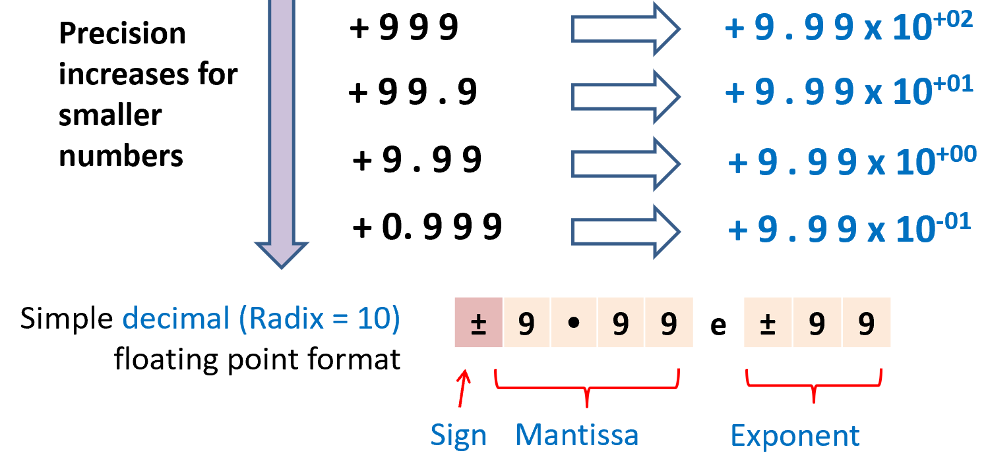

Normalization
- Multiple representations for same value in floating point representation  - Normalization → avoid synonymous representation by maintaining one non-zero digit before radix point  - Decimal → digit can be from 1 to 9  - Binary → digit is 1  - Maximise number of bits precision | 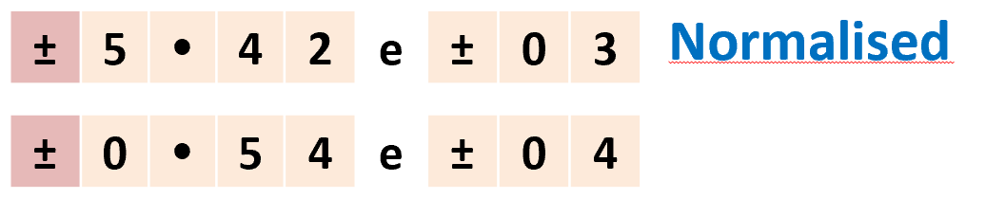  ----  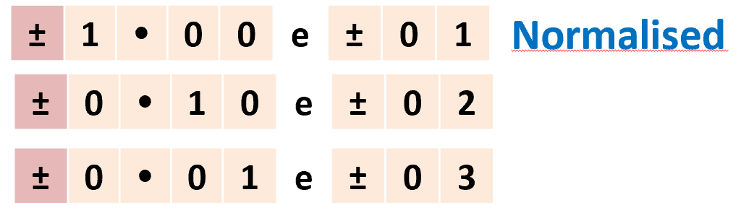

Underflow
- Normalization results in underflow in regions where values close to zero cannot be represented
- When value too small to be represented
- May cause programs to crash if not handled properly
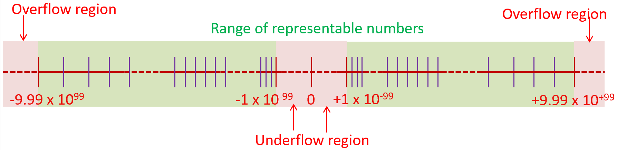

6.3 IEEE 754
IEEE Floating Point Standard
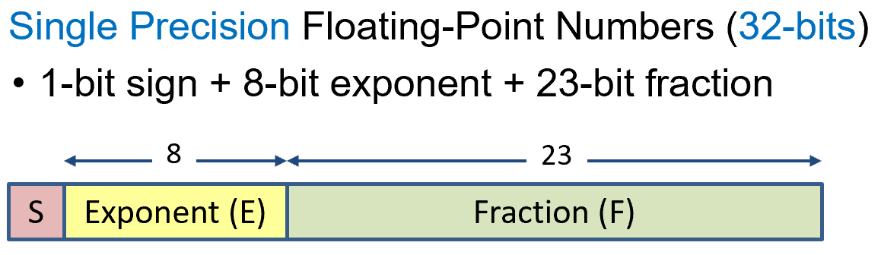 | 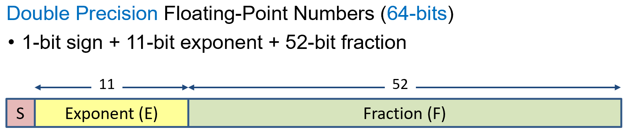

IEEE Normalized Numbers
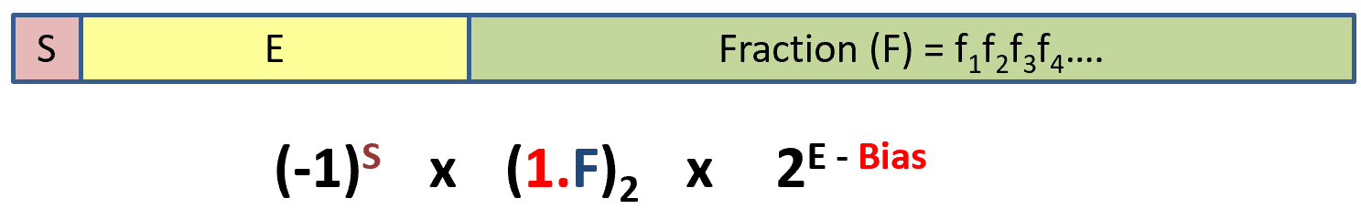
- Sign ⇒ 0 positive, 1 negative
- Exponent ⇒ Biased representation (0000 0001 to 1111 1110)
  - Value of exponent = E-Bias
  - Bias = 127 (single precision), 1023 (Double precision)
- Fraction ⇒ Assumes hidden 1. (not stored) for normalized numbers

Examples
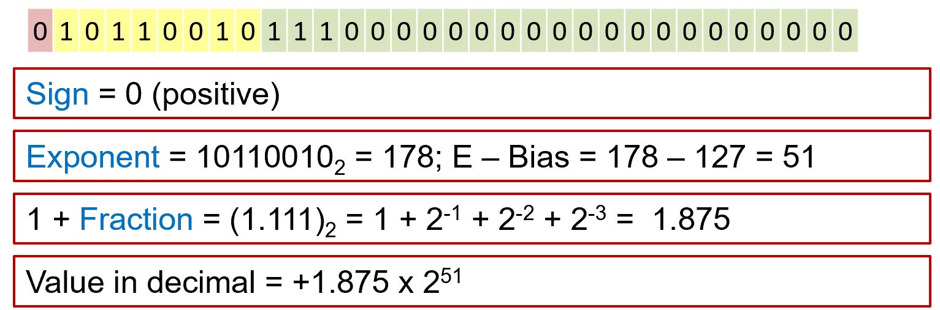 | 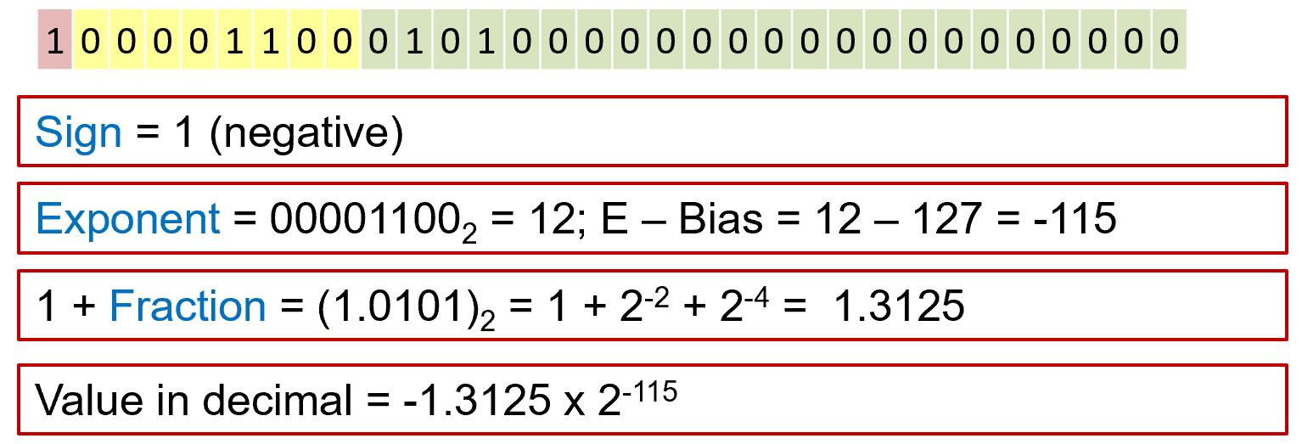

Representable Range for Normalized Single Precision
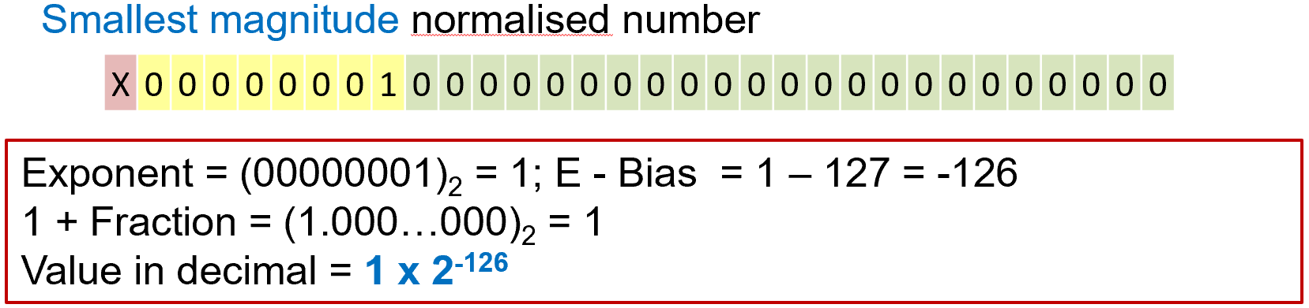 | 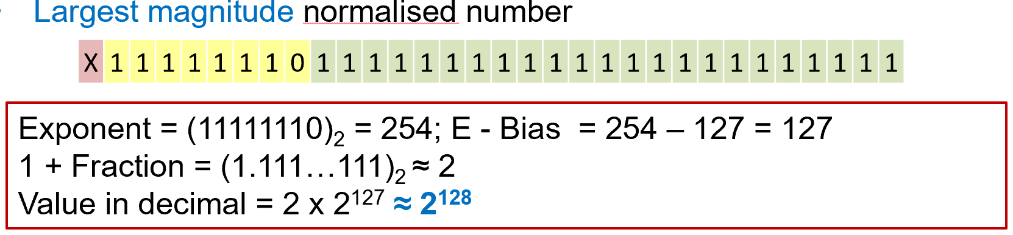

6.4 Computer Arithmetic related consideration during coding
Effects of 4 Operators
- Addition/Subtraction
  - Causes result to increase/decrease
  - When done sufficient amount of times, overflow occurs
  - Note range of data type used and width of registers & memory
- Multiplication
  - Arithmetic left shift
  - Overflow at Min or Max end of representable range
  - Similar consideration as Add/Sub
- Division
  - Logical shift right
  - Truncation of LSB leads to loss in precision
  - Reduces magnitude of result, gets further away from min/max of range

Effects of Rounding
- Removing LSB so that result can fit into representable bits
- Round up, down or to nearest representable number
- Limits imposed in width of representable bits from register width, data type et.
- Rounding error is incurred
- Common to have immediate register with width larger than regular data registers to allow intermediate processing to be done at higher precision, reducing rounding error

Rounding Error Mitigation
- Exponents must be aligned such that they are the same
- Guard digits used to maintain precision
- Intermediate register with wider width can also be used
- Rounding performed to ensure result fits into 3 sig digits of mantissa

Handling numbers of different magnitudes
- Order of evaluation can affect accuracy of result
- Add/subtract operands with similar size magnitude first

Maximising accuracy during computation
- Accumulate/Subtract numbers with small magnitude fist
- Take note of range of number system used
- Apply threshold to check for overflow if possible
- No overflow check done, take note of number/vale of accumulation/multiplication that can be done without triggering overflow
- Do division last as far as possible

Part 2 Appendix

Sizes
 | Decimal | Base 2
Pico | 10⁻¹² | -
Nano (n) | 10⁻⁹ | -
Micro (μ) | 10⁻⁶ | -
Mili (m) | 10⁻³ | -
Kilo | 10³ | 2¹⁰ = 1024
Mega | 10⁶ | 2²⁰
Giga | 10⁹ | 2³⁰
Terra | 10¹² | 2⁴⁰

Important Formula to Remember
Chapter 1 - Signal chain subprocessing
Baud rate ⇒ No of bits transferred per second
Chapter 2 - Computer Memory
Avg Rotational Delay (T_{RAV})  0.5 / RPS | Total Transfer Time (T_{T})  N / RPS * D_{S} * D_{T}
Chapter 3 - Cache
Cache Performance Related Terminologies
- Cache Hit → Data found in cache
- Cache Miss → Data not in cache
- Cache Hit Rate (H) → % of time data is found in cache
- Cache Miss Rate → %of time data not found in cache (1-H)

Effective Access Time
- Weighted acreage taking into account hit ratio & relative access times
  - EAT = H * AccessTimeForCache + (1-H) * MissPenalty
- Assuming data access to cache & main memory do not overlap
  - MissPenalty = AccessTimeForCache + AccessTimeForMainMemory
  - EAT = H * (AccessTimeForCache) + (1-H) * (AccessTimeForCache + AccessTimeForMainMemory)
Chapter 4

